
Front-End and Back-End Integration for AMS Project Management:
Implementation of Business Continuity Assessment and Change Management Features Using Artificial Intelligence

Luís Filipe Duarte Sousa

Mestrado em Tecnologias Digitais para o Negócio

Master’s Degree in, Digital Technologies for Business

Supervisor:
Prof. Dr. Rúben Filipe de Sousa Pereira, Assistant Professor,
ISCTE - Instituto Universitário de Lisboa

Co-Supervisor:
Prof. Dr. José Cascais Brás, Assistant Professor
ISCTE - Instituto Universitário de Lisboa

July, 2026
Contents

Chapter 1 1
Introduction 1
1.1. Context 1
1.2. Motivation 1
1.3. Objectives 2
1.4. Dissertation structure 2
Chapter 2 4
State of the art 4
2.1. Theoretical Background 4
2.1.1. Business Continuity 4
2.1.2. Change Management 4
2.1.3. Application Management Services (AMS) 4
2.2. Literature review 5
2.2.1. Databases and Query String Used 5
2.2.2. Eligibility Criteria 6
2.2.3. Article Selection 6
2.3. Related Work Synthesis 7
2.3.1. Business Impact Assessment 7
2.3.2. Governance & Compliance Mapping 10
2.3.3. AI-Driven enhancements 11
2.3.4. Lifecycle Analysis 14
2.3.5. Adaptative assessments 16
2.4. Synthesis and Research gap 18
Chapter 3 20
Research methodology 20
3.1. Problem identification and motivation 21
3.2. Organizational context 22
3.3. Objectives of the solution 22
3.4. Design and development 26
3.4.1 – Front-end layer 27
3.4.2 – Database layer 27
3.4.3 – Backend layer 29
3.4.4 – The AI engine 35
Chapter 4 42
Results and discussion 43
4.1. Overview of Evaluation results 43
4.2. First Evaluation Iteration 44
Chapter 5 54
Conclusion 54
References 55
Appendices 57
Appendix A 57

List of figures
Figure 1 - Prisma application process 6
Figure 2 - Design science research model 21
Figure 3 - High-level conceptual architecture of the artifact developed 27
Figure 4 - Conceptual entity–relationship model supporting the assessment artifact 28
Figure 5 - Backend layer logical structure 31
Figure 6 - NBQ selection workflow 39
Figure 7 - Distribution of respondents by professional role group 46
Figure 8 - Positive responses by functional area in the first evaluation iteration 49
Figure 9 - Mean score by functional area in the first evaluation iteration 50

List of tables
Table 1 - Query string 5
Table 2 - Exclusion criteria 7
Table 3 - Analysis vector vs Articles founded 7
Table 4 - AI enhancements for each article 11
Table 5 - Development phase of each article 14
Table 6 - Application’s functional domains 23
Table 7 - Functional mapping of the Login endpoint 32
Table 8 - Functional mapping of the Administration endpoints 33
Table 9 - Functional mapping of the Clients endpoints 34
Table 10 - Functional mapping of the Assessment endpoints 35
Table 11 - Business Continuity assessment topics 36
Table 12 - Change management assessment topics 37
Table 13 - Example 1 of an assessment question 38
Table 14 - Example 2 of an assessment question 38
Table 15 - Stopping criteria for topic evaluation 41
Table 16 - Characterization of first-iteration respondents 45
Table 17 - Distribution of evaluation sessions by format 47
Table 18 - General perception of the proposed assessment approach 47
Table 19 - Functional areas evaluated in the first iteration 48
Table 20 - Main themes identified in the open-ended responses 51

Chapter 1

Introduction
  - Context
Business continuity in software systems is essential for organizations to maintain key operations during disruptions. Within Application Management Services (AMS), ensuring continuous operation, resilience, and adaptability of both front-end and backend components is critical, especially when downtime can lead to significant operational and financial losses. Disruptions such as Application Programming Interface (API) failures or User Interface (UI) issues can rapidly impact service availability and user trust, prompting AMS solutions to adopt Artificial Intelligence (AI)-driven mechanisms for real-time monitoring and proactive risk management [1] [2].
Recent research highlights the importance of robust AI-driven systems and foundational software libraries, emphasizing rigorous fault injection and failure analysis to prevent disruptions [2] [3]. Adopting risk-centric lifecycle frameworks enhances software quality, reduces downtime, and ensures Service Level Agreement (SLA) compliance through integrated risk management [4]. Additionally, AI integration across software engineering tasks like requirements traceability, testing, and debugging further improves the reliability and maintainability of AMS-managed systems [1].
Security considerations are also critical, with proactive security measures addressing vulnerabilities that could compromise business continuity in AI-driven systems [5]. Thus, combining AI enhancements, lifecycle governance, and robust security practices collectively ensures effective business continuity and change management in dynamic environments.
  - Motivation
In the current landscape of IT services, AMS has evolved from a purely operational function into a critical enabler of organizational resilience and digital continuity. As enterprises increasingly depend on complex and constantly evolving software ecosystems, ensuring the stability and adaptability of these systems has become both more challenging and more strategic.
Despite this growing reliance, organizations often lack structured and consistent approaches to assess their readiness in terms of business continuity and change management within AMS contexts. Existing practices are frequently fragmented, experience-driven, and highly dependent on individual expertise, which introduces variability, limits scalability, and increases the risk of misaligned decisions. This is particularly critical in environments where inadequate continuity planning or poorly managed changes can lead to significant operational disruptions and financial loss.
At the same time, the emergence of AI presents a unique opportunity to enhance decision-making processes by enabling more adaptive, data-driven, and context-aware assessments. However, the integration of AI into AMS assessment practices remains largely unstructured, with a lack of clear frameworks that guide its effective and responsible use.
This gap highlights the need for a systematic approach that not only standardizes the evaluation of business continuity and change management capabilities but also leverages AI to support dynamic assessment processes. Such an approach can contribute to more reliable maturity evaluations, improved governance, and ultimately, more resilient AMS operations.
  - Objectives
The goal of this thesis is to develop a practical prototype application specifically tailored to assist the organization in assessing the potential impacts of new projects from a business continuity and change management perspective. This AI-based tool will support strategic decision-making processes by providing predictive insights into possible disruptions and changes, ultimately enabling the organization to maintain operational stability and effectively manage project-related transitions.
To support the design of the proposed artifact, this research also seeks to analyze the impact of AI across different phases of the software development lifecycle. This analysis aims to identify relevant practices, opportunities, and limitations that inform the design and implementation of the AI-driven assessment engine.
  - Dissertation structure
This dissertation is organized into five main chapters, which progressively address the research problem.
Chapter 1 introduces the context of the study, outlining the motivation and defining the objectives that guide the development of this research.
Building on this foundation, Chapter 2 presents the theoretical background, introducing key concepts such as AMS, Business Continuity, and Change Management. It also includes a review of the state of the art, analyzing existing literature and current approaches related to the use of AI in software engineering and service management contexts. This chapter establishes the conceptual and scientific basis that supports the proposed solution.
Following the theoretical grounding, Chapter 3 describes the research methodology adopted in this study. It details the approach used to design and develop the proposed artifact, as well as the methods applied to ensure its relevance and validity.
Based on the defined methodology, Chapter 4 presents the results and discussion, including the implementation of the prototype and the analysis of its effectiveness in addressing the identified problem. This chapter also discusses how the proposed solution contributes to improving decision-making processes in AMS contexts.
Finally, Chapter 5 concludes the dissertation by summarizing the main findings and contributions, discussing the limitations of the study, and suggesting directions for future research.

Chapter 2

State of the art
  - Theoretical Background
    - Business Continuity
Business Continuity refers to the capability of an organization to continue delivering products or services at acceptable predefined levels following a disruptive incident. This concept highlights the importance of maintaining operational resilience in the face of failures, ensuring that critical systems and services remain functional even under adverse conditions. In the context of AMS, Business Continuity is closely related to the ability to manage system changes, incidents, and disruptions without significantly impacting service delivery [6].

    - Change Management
Change Management refers to a sequence of processes used to ensure that significant organizational changes are implemented in a controlled and systematic manner, while also guiding how individuals are prepared and supported to successfully adopt such changes to achieve organizational objectives [7].

    - AMS
AMS refers to the set of operational, managerial, and strategic activities required to ensure the effective operation, maintenance, and evolution of an organization’s application landscape. These activities encompass not only the technical execution of application-related tasks but also the organizational and strategic mechanisms that support them. Application management involves coordinated management of application development, operation, and maintenance in alignment with business requirements. Furthermore, AMS can be structured across three key dimensions: sourcing, application portfolio management, and governance, which together ensure the availability of resources, the alignment of applications with business needs, and the establishment of efficient processes and organizational structures [8] .

  - Literature review
The research was search using strings representing the main research topics—keywords such as requirements, application maintenance, backend, and business continuity were employed in the search. The guidelines of PRISMA (Preferred Reporting Items for Systematic Reviews and Meta-Analyses) were followed—a set of guidelines designed to ensure transparency, methodological rigor, and reproducibility in conducting and reporting systematic reviews, thus ensuring a careful and documented selection of studies included in the analysis [4].

2.2.1. Databases and Query String Used
The databases used to gather articles were as follows:
- Springer Link - https://link.springer.com/
- ACM Digital Library - https://dl.acm.org/
- Scopus - https://www.scopus.com/
- Web of Science - https://www.webofscience.com/
To establish the collection of articles for this research, a query string incorporating all the relevant research topics was designed and executed within each of the listed databases. The query string resulted from the conjunction of the following terms:
Table 1 - Query string
Term(s) – if multiple, grouped with OR | Objective:
“requirements” | Requirements analysis in software maintenance
“application maintenance”, ”software maintenance” | Address application/software maintenance
“backend”, “back-end” | Focus on backend component
“business continuity”, “change management”, “artificial intelligence” | Use of AI, business continuity practices, and change management

The literature search was conducted using the following query string: (“requirements”) AND (“application maintenance” OR “software maintenance”) AND (“backend” OR “backend”) AND (“business continuity” OR “change management” OR “artificial intelligence”)

2.2.2. Eligibility Criteria
Regarding other filters applied, these included publication date (from 2017 to 2025) and language (only articles written in English). The types of documents sought during data collection were journal articles, conference papers, reviews, and articles from journals.

2.2.3. Article Selection
In the initial phase, the query string with the previously mentioned keywords was entered into each of the search engines. Duplicates were then removed, and the inclusion/exclusion criteria were applied. The article filtering process is illustrated in Figure 1, and the inclusion/exclusion criteria considered are presented in Table 2.

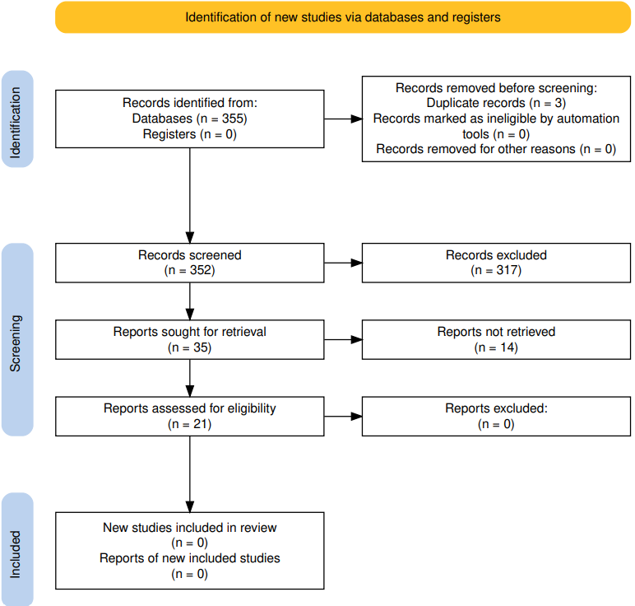
Figure 1 - Prisma application process

Table 2 - Exclusion criteria
Inclusion Criteria: | Exclusion criteria:
Journals, books, newsletters, articles, conference papers | Documents published before 2017
Related to the specified keywords | Not written in English
Documents in English | Not relevant to the study topic
Documents published from 2017 onwards
  - Related Work Synthesis
Table 3 presents a thematic classification of the selected articles based on four key analysis vectors relevant to the research: AI-Driven Enhancements, Business Impact Assessment, Lifecycle Analysis, Governance & Compliance Mapping and Dynamic Assessments. Each vector is associated with the identifiers of articles that address or contribute to that topic.

Table 3 - Analysis vector vs Articles founded
Analysis vector: | Articles founded:
AI-Driven Enhancements | [1],[9], [10], [6], [11], [12]
Business Impact Assessment | [2], [3], [5], [13], [14],
Lifecycle Analysis | [1], [6], [9], [13]
Governance & Compliance Mapping | [1],[13]
Adaptative Assessments | [17],[18],[19],[20],[21]

    - Business Impact Assessment
Business Impact Assessment (BIA) is critically addressed in Yu et al. (2025) [2], where the authors emphasize the real-world consequences of AI system failures across multiple layers of the AI stack. They highlight that failures can lead to degraded user experience and significant financial losses, particularly in high-stakes domains such as healthcare and finance. For instance, the authors note that ChatGPT experienced 173 outages in 2023, with a maximum user impact of 427 minutes, underscoring the operational and reputational risks associated with system downtime. Moreover, the survey stresses the importance of fault injection (FI) and failure analysis (FA) not only as technical tools but as mechanisms to proactively identify vulnerabilities that could disrupt service continuity and violate SLAs.
Building on this need to prevent failures at a foundational level, the article by Zhang et al. (2025) [3] underscores the critical role of deep learning (DL) library testing in ensuring the reliability, efficiency, and safety of AI systems, which directly aligns with the goals of BIA. The authors highlight that bugs in DL libraries—such as TensorFlow and PyTorch—can propagate to higher-level applications, leading to erroneous predictions, system crashes, and performance degradation.
While Zhang et al. focus on the technical reliability of AI libraries, the ER²C SDMLC model proposed by Sadler [13] directly addresses the core concerns of BIA by embedding risk management into every phase of the systems development and maintenance life cycle. The model shifts the focus from project-centric to release-centric governance, recognizing that many enterprise systems evolve continuously through operational changes rather than discrete projects. This perspective is crucial for ensuring business continuity, as it mandates that all releases—whether major or minor—undergo risk-based evaluation and quality assurance. The model introduces differentiated levels of rigor based on the assessed risk impact of each release, using quantifiable metrics such as unit test coverage, regression test coverage, and functional correctness to enforce thresholds aligned with the potential business consequences of failure. By doing so, it enhances SLA compliance, reduces downtime, and supports agile change management without compromising system integrity. Moreover, the model’s emphasis on “freedom from risk” as a dimension of quality-in-use aligns with ISO/IEC 25022:2016, reinforcing its applicability in environments where user satisfaction and operational resilience are paramount. This makes ER²C SDMLC a valuable framework for integrating AI-driven risk assessment into backend software maintenance strategies aimed at safeguarding business operations.
Complementing this systemic view, the study by Özkan et al. (2023) [14] provides a compelling case for integrating BIA into software maintenance and architectural refactoring practices, particularly through the lens of Domain-Driven Design (DDD). Conducted in a high-stakes industrial context involving safety-critical automotive software, the research highlights how architectural issues—such as code duplication, poor encapsulation, and centralized repositories—can significantly hinder maintainability, scalability, and operational resilience. By applying DDD principles, the authors achieved measurable improvements in modularity, testability, and reusability, as validated through ISO/IEC 25010-aligned metrics and modified Technology Acceptance Model (mTAM) scores. Crucially, the refactoring was deliberately scoped to avoid disrupting business continuity, reflecting a risk-aware approach to change management. The study underscores that DDD not only enhances technical quality but also aligns software architecture more closely with business domains, thereby reducing the cognitive load on developers and improving responsiveness to evolving requirements. These outcomes directly support the goals of BIA by mitigating operational risks, ensuring SLA compliance, and enabling agile yet controlled evolution of mission-critical systems.
Finally, extending the scope of BIA into the security domain, Chen and Babar (2024) [5] underscore the critical need for BIA in the context of machine learning-based software systems (MLBSS), particularly as these systems are increasingly deployed in safety-critical and high-stakes environments. The authors highlight that security vulnerabilities — whether stemming from data poisoning, model extraction, or system-level attacks — can lead to catastrophic operational failures, data breaches, and service disruptions. Their comprehensive survey reveals that many of these vulnerabilities are not adequately addressed by current software engineering practices, especially during early lifecycle stages such as requirements engineering and data management. This gap directly threatens SLA compliance, system availability, and user trust. By advocating for secure development practices aligned with the CIA triad (Confidentiality, Integrity, Availability) and emphasizing the need for continuous post-deployment monitoring, the study provides a framework for assessing and mitigating business risks. The integration of threat modeling, secure data validation, and model robustness testing into the development lifecycle supports proactive risk management, making BIA a foundational element for ensuring the resilience and reliability of MLBSS in production environments.
Brás et al. [15] explore the relationship between Business Continuity Management and Intelligent Process Automation by mapping ISO 22301:2019 and IEEE 2755.2:2020. Their study highlights that, although both domains are supported by established standards and frameworks, limited research has addressed how they can complement each other. The proposed mapping reinforces the relevance of integrating continuity practices into automation initiatives, supporting more resilient, structured, and continuously improved organizational processes.
In a subsequent study, Brás et al. [16] analyze the integration of Intelligent Process Automation within business continuity auditing in the Portuguese financial sector, demonstrating how automation can support audit activities, improve operational efficiency, and provide KPI-based decision support for management. Although the study focuses on the banking audit context, its findings are relevant to this research, as they highlight the potential of automation-based artifacts to enhance monitoring, resilience, and decision-making in business continuity processes.

    - Governance & Compliance Mapping
In the context of regulated software-intensive industries, governance and compliance mapping is increasingly intertwined with the adoption of DL techniques in software engineering. Chen et al. (2025) [1] highlight the critical role of DL in enhancing traceability across the software lifecycle, particularly through models such as TraceBERT and GRU-based architectures that support change management by linking requirements to design, code, and test artifacts. This traceability is essential for demonstrating compliance with standards such as ISO/IEC 29148, ensuring that changes are systematically documented and auditable. However, the authors also underscore a persistent challenge: the limited interpretability of DL models, which impedes their auditability and explainability—key requirements in regulated environments. While DL models have shown promise in automating fault localization and program repair, thereby supporting business continuity through reduced downtime, their opaque decision-making processes raise concerns for compliance officers and auditors. The paper calls for future research into interpretable DL models and standardized evaluation frameworks to bridge the gap between technical performance and regulatory accountability, thereby aligning AI-driven software engineering with governance and compliance imperatives.
Extending this discussion from the model-level limitations of DL to the broader software governance lifecycle, Sadler (2020) [13] proposes the ER²C SDMLC (Enterprise Release Risk-Centric Systems Development and Maintenance Life Cycle), a governance-aligned framework that integrates risk-based rigor into both development and maintenance activities. Unlike traditional project-centric models, ER²C SDMLC treats systems as a continuum of releases and embeds risk assessment and control mechanisms throughout the life cycle, in accordance with ISO 31000:2009 and ISO/IEC 15288:2015. The model enforces differentiated levels of rigor based on quantified release risk impact levels, using intrinsic quality metrics (e.g., unit test coverage, regression test coverage) and extrinsic acceptability criteria (e.g., approvals, endorsements) to ensure traceability, auditability, and compliance. This approach aligns with ITIL-aligned change and release management practices by standardizing governance across all release types — whether project-based or operational — thus reducing the likelihood of quality degradation in quick-fix or low-rigor maintenance environments. By integrating risk management into every release and enabling dynamic tailoring of controls, ER²C SDMLC enhances explainability and accountability in software delivery, supporting business continuity and regulatory compliance in complex enterprise settings.

    - AI-Driven enhancements
Table 4 summarizes how various studies integrate AI techniques into software engineering tasks. Each article is mapped to a specific AI-enhanced capability, illustrating the breadth of AI applications across the software development lifecycle. From automated documentation and natural language processing (NLP) for code interpretation to large language models (LLMs) for test generation and debugging, these studies collectively highlight the transformative role of AI in modern software engineering.
Table 4 - AI enhancements for each article
Article | AI-enhancement description
[9] | Source code documentation (automated summarization, pseudocode generation)
[10] | Naturalistic programming (NLP for code interpretation and translation)
[1] | Broad software engineering tasks (requirements, code generation, testing, debugging)
[6] | Web-form test generation using LLMs
[11] | Mining unstructured data in software repositories using NLP
[12] | AI for software debugging and debugging AI systems

Rai et al. (2022) [9], explains that AI—particularly DL — plays a central role in advancing automated source code documentation. The authors provide a comprehensive survey of AI-driven techniques, highlighting how neural architectures such as sequence-to-sequence models, attention mechanisms, graph neural networks (GNNs), and transformers have revolutionized the field. These models enable the generation of natural language summaries, method names, and pseudocode from raw source code by learning complex mappings between code structures and human-readable descriptions. The review emphasizes that DL approaches have surpassed traditional template- and information retrieval-based methods in both performance and flexibility, especially in handling diverse programming languages and large-scale corpora. Moreover, the integration of structural representations like abstract syntax trees (ASTs) and call graphs into neural models has enhanced the semantic understanding of code, further improving documentation quality. The article also notes the growing use of transformer-based models (e.g., CodeBERT, TranS3) and hybrid architectures that combine multiple representations and learning paradigms. Overall, the work illustrates how AI-driven enhancements are not only automating but also elevating the quality and scalability of source code documentation, marking a significant shift in software engineering practices.
Expanding from the domain of source code documentation to broader programming environments, Pulido-Prieto and Juárez-Martínez (2017) [10] highlight the foundational yet indirect role of AI in enabling naturalistic programming technologies. While AI is not the central focus of their survey, they emphasize how techniques from NLP — such as anaphora resolution, commonsense reasoning, and probabilistic modeling—are essential for interpreting, disambiguating, and translating human language into executable code. Several tools they review rely on AI-driven components to bridge the gap between user intent and formal programming constructs, often incorporating ontologies, controlled natural languages, and heuristic-based parsing to manage ambiguity and context sensitivity. Although many implementations remain domain-specific or constrained by predefined grammars, their effectiveness hinges on AI’s ability to process linguistic nuance. As such, AI-driven enhancements are instrumental in advancing the expressiveness, usability, and accessibility of programming environments that aim to align more closely with human cognitive and linguistic models.
Chen et al. (2025) [1] present a comprehensive, task-oriented survey of how DL has been applied across twelve major subareas of software engineering, including requirements engineering, code generation, testing, bug localization, and program repair. Rather than focusing solely on the DL models themselves, the authors emphasize how these models have been adapted to address specific challenges in each subdomain. They highlight that DL has enabled significant improvements in automation, accuracy, and scalability across many software engineering tasks. For instance, in requirements engineering, models like BERT and CNNs have been used for tasks such as requirements classification and traceability, often achieving precision and recall above 80%. In code generation and summarization, transformer-based models and graph neural networks have shown strong performance, especially when incorporating structural code representations like ASTs and CFGs. However, the authors also identify persistent challenges, including the scarcity of high-quality, domain-specific training data, limited model interpretability, and difficulties in generalizing across programming languages. They advocate for future research to focus on improving dataset quality, enhancing model transparency, and exploring the integration of large language models (LLMs) to further advance the field.
One promising application of LLMs within this broader context is demonstrated by Tao Li et al., (2025) [6] investigate the application of AI through LLMs to automate web-form test generation. The authors evaluate 11 state-of-the-art LLMs—including GPT-4, GLM-4, and Baichuan2—on their ability to produce valid and context-aware test inputs for 146 web forms across 30 open-source Java web applications. Their AI enhancement strategy is structured around three core components: HTML pruning, which simplifies complex form structures while preserving essential semantic elements; context construction, which transforms web-form HTML into structured representations using raw, LLM-processed, or parser-processed formats; and prompt engineering, which guides LLMs to produce accurate test cases. The study demonstrates that structured prompts—particularly those based on parser-processed HTML—significantly improve test success rates, with GPT-4 achieving the highest effectiveness. This work illustrates the potential of LLMs to intelligently interpret and interact with complex web interfaces, offering practical insights into prompt design and model selection for AI-assisted software testing.
In parallel, another key area where AI-driven techniques show great potential is in the mining of unstructured data, as explored by Som Gupta and S. K. Gupta (2019) [11] explore in their review the application of NLP techniques in mining unstructured data from software repositories. The authors highlight that over 80% of the data in repositories such as GitHub, Bugzilla, and Stack Overflow is unstructured and primarily in natural language, making NLP a critical tool for extracting meaningful insights. Their study categorizes NLP applications across several key areas, including sentiment analysis, summarization, traceability, norms mining, and mobile analytics. They examine how NLP techniques—such as part-of-speech tagging, dependency parsing, and semantic analysis—are used to process artifacts like bug reports, commit messages, and user reviews. The paper also discusses the strengths and limitations of NLP in this domain, emphasizing the need for hybrid approaches that combine NLP with machine learning and information retrieval to improve accuracy and effectiveness. This work provides a foundational understanding of how NLP can support software engineering tasks by transforming unstructured textual data into actionable knowledge.
Finally, connecting AI enhancements to the software debugging domain, Yi Song et al. (2024) [12] present a comprehensive review of the evolving intersection between AI and software debugging, presenting a dual-perspective framework: AI for software debugging (AI4SD) and software debugging for AI (SD4AI). The authors analyze 165 primary studies published between 2016 and early 2021, categorizing them into AI-enhanced debugging techniques—such as fault localization and automated program repair—and debugging strategies aimed at improving the reliability of AI systems themselves. Their work highlights how AI models, particularly DL architectures like CNNs and RNNs, are increasingly used to automate and enhance traditional debugging tasks. Conversely, they also emphasize the growing need to debug AI systems, especially in safety-critical domains, by applying software engineering principles to identify and fix faults in data, model architecture, and AI libraries. The study not only maps the current landscape of AI and debugging integration but also identifies key challenges, such as overfitting in automated repairs and the lack of real-world fault datasets, while proposing future research directions to bridge these gaps.
    - Lifecycle Analysis
Table 5 provides a comparative overview of how the four selected studies address different phases of the Software Development Lifecycle (SDLC).

Table 5 - Development phase of each article
Article | Lifecycle phase | Focus Area
[9] | All phases, with emphasis on Maintenance | Documentation (process & product), automation of documentation for maintainability
[1] | Requirements, Design, Implementation, Testing, Maintenance | DL applications across 12 SE subareas, lifecycle-aligned analysis
[13] | Entire lifecycle (from Needs Analysis to Retirement) | ER²C SDMLC model: release-centric, risk-managed lifecycle governance
[6] | Testing | LLM-based web form test automation

The article by Rai et al. (2022) [9] integrates lifecycle analysis within the broader context of software documentation, particularly emphasizing its role in software maintenance. The authors distinguish between process and product documentation, highlighting how documentation supports various phases of the SDLC. Process documentation encompasses standards, schedules, working papers, reports, and communication logs, all of which trace the evolution and management of software projects. Product documentation, including user and system documentation, is crucial during the operational and maintenance phases. The paper underscores that source code documentation—an integral part of system documentation—is vital for understanding and modifying code during maintenance. This lifecycle-aware perspective is further reinforced by the authors’ focus on automating documentation generation to reduce the time and cost associated with manual documentation, thereby enhancing maintainability and long-term software quality.
While Rai et al. focus on documentation as a key component throughout the SDLC, Chen et al. (2025) [1] adopts a lifecycle-oriented perspective to explore the integration of DL techniques across the software engineering discipline. It explicitly aligns its analysis with the classical phases of the software development lifecycle—requirements, design, implementation, testing, and maintenance—by organizing twelve major software engineering subareas accordingly. These subareas include tasks such as requirements engineering, code generation, testing, and bug report management, each mapped to relevant lifecycle stages. This structured approach not only highlights the widespread impact of DL across the entire software lifecycle but also reveals a research concentration in the maintenance phase. By framing DL applications within the lifecycle model, the paper provides a comprehensive and coherent view of how AI-driven methods are reshaping software engineering practices from inception to evolution.
Further advancing the notion of lifecycle integration, Sadler [13] introduces the ER²C SDMLC model, a novel systems development and maintenance life cycle framework that redefines the traditional software lifecycle by emphasizing release-centricity and risk management. Unlike conventional project-based models that focus primarily on initial system delivery, ER²C SDMLC treats software as a continuum of releases, integrating both development and maintenance under a unified governance structure. The model aligns with ISO 15288 and ISO 31000 standards, embedding risk assessment and quality metrics throughout all lifecycle stages—from needs analysis to retirement. By categorizing releases based on scope, risk, and deployment environment, and applying varying levels of rigor accordingly, the model ensures that both major and minor changes are subject to appropriate quality assurance. This lifecycle approach not only enhances traceability and adaptability but also minimizes end-user exposure to risk, making it particularly suitable for enterprise-scale systems in dynamic operational environments.
This study by Li et al. (2025) [6] contributes to the software development lifecycle by focusing on the testing phase, specifically the automation of web-form testing using large language models (LLMs). The authors evaluate 11 LLMs across 146 web forms from 30 open-source Java web applications, assessing their ability to generate valid test inputs based on contextual HTML information. By proposing structured prompt designs and HTML pruning techniques, the study enhances the precision and effectiveness of automated test generation. Although the paper does not address the full SDLC, it significantly advances the testing process—an essential lifecycle phase—by integrating AI-driven methods that improve test coverage, reduce manual effort, and support continuous quality assurance in modern web development workflows.
    - Adaptative assessments
The concept of selecting the Next Best Question (NBQ) is closely related to adaptive questioning strategies, where each subsequent question is chosen based on the information gained from previous responses. As demonstrated by Rzeniewicz et al. [17], question-based search algorithms operate iteratively by maintaining a dynamic set of candidate concepts and refining it through user interaction. At each iteration, the system evaluates the similarity between the accumulated answers and each candidate representation, typically using vector-based similarity measures such as cosine similarity. Based on this evaluation, a subset of the most relevant candidates is retained, while less relevant ones are progressively discarded.
The selection of the next question is then driven by an information-theoretic criterion, such as Information Gain, which identifies the question that best partitions the current candidate space and maximizes the reduction of uncertainty. This ensures that each interaction contributes meaningfully to narrowing down the possible outcomes. The process continues iteratively until a stopping condition is reached, such as achieving sufficient confidence in the result or exhausting the available questions.
A practical implementation of the NBQ approach can be observed in AI-driven interview systems, such as the Joinect platform [18]. In this context, the system dynamically selects the next question based on its ability to best partition the remaining set of feasible solutions. Starting from a large solution space, general questions are asked first to eliminate broad categories, while more specific questions are introduced only when the candidate space has been sufficiently reduced. This adaptive mechanism ensures that only relevant questions are asked, thereby improving efficiency and reducing unnecessary interactions. Furthermore, the sequence of questions is not predefined but evolves dynamically according to user responses, demonstrating the flexibility and effectiveness of NBQ-based systems in real-world applications.
Mixed-initiative problem solving approaches provide a strong foundation for NBQ mechanisms, particularly in scenarios where complete information is not available. In such systems, the selection of the next question is dynamically guided by the current state of knowledge, aiming to confirm a target outcome class with minimal interaction. The approach proposed by McSherry (2008) [19] demonstrates how decision-tree-based systems can iteratively select the most informative attribute to query, effectively implementing an NBQ strategy. By incorporating mechanisms to handle unknown responses and applying meta-level reasoning to determine when no solution is possible, this model ensures both efficiency and robustness in interactive decision-making processes.
In this study McSherry [20], the NBQ logic is applied in the context of interactive case-based reasoning for sequential diagnosis. The system dynamically selects the next question according to its usefulness for distinguishing between competing diagnostic hypotheses. Rather than following a fixed questionnaire, CBR Strategist applies strategic question-selection mechanisms such as confirming the target hypothesis, eliminating the most likely alternative, validating the current diagnosis, or opposing competing explanations. This allows the system to progressively reduce the set of possible cases while maintaining flexibility in the presence of missing or uncertain information. When the user is unable to answer a question, the system does not terminate the process; instead, it selects the next most useful question, showing how adaptive questioning can support robust and efficient decision-making in diagnostic contexts.
Tuval et al. [21] approach the NBQ problem from the perspective of adaptive feature acquisition, where the system dynamically decides which piece of information should be requested next to improve the prediction process while reducing unnecessary acquisition costs. This perspective is particularly relevant for adaptive assessment systems, as each question can be interpreted as a feature whose value contributes to refining the current understanding of the assessed subject. Therefore, the NBQ mechanism supports a more efficient interaction by selecting only the most informative questions at each stage of the assessment process.
  - Synthesis and Research gap
The literature reviewed in this chapter demonstrates that Business Continuity, Change Management, lifecycle governance, AI-driven software engineering, and adaptive assessment mechanisms have each been addressed by previous research. Studies related to Business Continuity highlight the importance of risk identification, operational resilience, failure analysis, auditability, security, and automation-supported decision-making [2], [5], [15], [16]. Similarly, research on lifecycle governance and change-oriented software maintenance emphasizes the need for controlled releases, traceability, compliance, and structured risk management mechanisms capable of reducing operational disruption [1], [13], [14]. In parallel, recent work on AI in software engineering shows how AI techniques can support activities such as requirements traceability, testing, debugging, documentation, and software maintenance [1], [6], [9], [12]. However, these research streams are often treated independently, with limited integration into a unified assessment approach specifically designed for AMS.
The first gap therefore concerns the lack of an integrated framework that combines Business Continuity and Change Management assessment within the specific operational context of AMS. Existing studies provide valuable insights into risk management, software quality, continuity practices, governance, and maintenance processes [5], [13], [15], [16], while other works address application management as a broader organizational and operational discipline [8]. Nevertheless, the literature does not fully address how AMS teams can systematically evaluate their readiness across Business Continuity and Change Management dimensions in a repeatable, comparable, and operationally useful manner. This limitation is particularly relevant because AMS environments are characterized by continuous service delivery, heterogeneous client contexts, evolving application portfolios, and frequent operational changes. As a result, organizations require assessment mechanisms that are not only theoretically grounded but also capable of supporting practical decision-making in real service management contexts.
A second gap relates to the limited use of adaptive questioning mechanisms in organizational maturity assessments. The literature on adaptive assessments and NBQ demonstrates that dynamic question selection can improve efficiency by choosing the most informative question according to the current state of knowledge [17], [21]. Previous studies apply these principles in domains such as interactive question-based search, intelligent interviews, mixed-initiative problem solving, case-based reasoning, sequential diagnosis, and adaptive feature acquisition [17] – [21]. These approaches show that adaptive questioning can reduce uncertainty, handle incomplete information, avoid unnecessary interactions, and progressively refine the system’s understanding of the problem being assessed [17], [19], [20]. Nevertheless, their application to the assessment of Business Continuity and Change Management maturity in AMS environments remains underexplored.
A third gap concerns the operationalization of AI-supported assessments into practical enterprise artifacts. Many of the reviewed studies propose models, algorithms, or isolated AI techniques, such as DL for software engineering tasks, LLM-based test generation, AI-supported debugging, or adaptive feature acquisition [1], [6], [12], [21]. However, fewer studies address how such mechanisms can be embedded into a modular backend platform capable of managing assessment sessions, storing structured responses, calculating maturity indicators, ensuring traceability, and exposing results through interoperable APIs. In AMS contexts, this implementation perspective is essential, since assessments must be auditable, reusable, secure, and adaptable to different clients, projects, service scopes, and governance requirements [8], [13], [15].
Furthermore, traditional assessment approaches tend to rely on static questionnaires or manual evaluation processes. Although such approaches may provide a basic structure for data collection, they are often rigid, repetitive, and insufficiently sensitive to the specific characteristics of each assessment context. The literature on adaptive questioning suggests that question selection should instead be guided by relevance, information gain, user responses, or the expected value of acquiring additional information [17], [19], [21]. This creates a gap between the potential of adaptive AI-based mechanisms identified in literature and the actual practices commonly used to assess operational maturity in AMS environments.
Therefore, this research addresses the identified gap by proposing an AI-supported framework for adaptive AMS assessments focused on Business Continuity and Change Management. The proposed framework integrates structured assessment topics, maturity scoring, contextual information, and an NBQ engine into a modular backend artifact. By doing so, it aims to support more efficient, standardized, traceable, and context-aware evaluations. This contribution extends existing literature by applying adaptive questioning principles to a new domain: the evaluation of organizational readiness and maturity within AMS service delivery contexts.

Chapter 3

Research methodology
For this research, the Design Science Research (DSR) methodology was adopted as the guiding scientific approach, as proposed by Peffers et al. [22].
Given that AMS environments frequently face complex, heterogeneous and evolving operational challenges—particularly in what concerns Business Continuity and Change Management readiness—traditional linear approaches are insufficient to capture the dynamic nature of these problems. In modern organizations, information systems are increasingly shaped by flexible architectures, distributed services, intelligent decision components, and automated integration layers. Consequently, designing artifacts for such contexts demands contemporary, adaptive and innovation-driven solutions.
Accordingly, the DSR methodology was selected because it emphasizes the creation and evaluation of novel artifacts, grounded both in theoretical foundations and in real organizational needs. In this study, the artifact corresponds to a backend platform for AMS assessments, enriched by an AI-based NBQ engine capable of generating adaptive questionnaires and processing user responses received from the front-end. DSR is particularly suitable for this type of solution, as it requires a rigorous evaluation of the artifact’s utility, quality and effectiveness, ensuring that the functionalities introduced contribute to measurable improvements in the organization’s assessment capability, operational maturity, and overall decision-making processes.
As described by Peffers et al. [22], the DSR model incorporates six core activities in a nominal sequence, which guide the development of the artifact throughout the research process. These activities—Problem Identification and Motivation, Objectives of a Solution, Design and Development, Demonstration, Evaluation, and Communication—were followed and adapted to the context of this study and are illustrated in Figure 2.
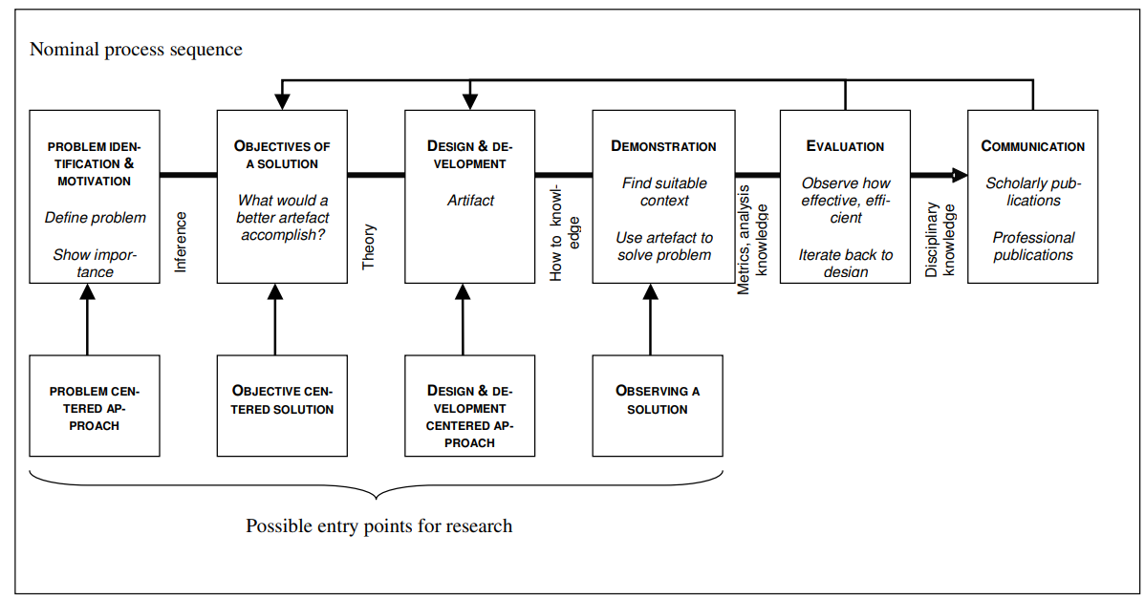
Figure 2 - Design science research model

3.1. Problem identification and motivation
This research emerged from a concrete need identified within a multinational IT consulting organization, where AMS teams were facing recurring challenges in assessing their readiness for Business Continuity and Change Management activities. Existing assessment processes were largely manual, heterogeneous and dependent on individual interpretation, relying on static questionnaires or spreadsheets that did not provide consistent or comparable insights across different services or clients.
In this organizational context, managers and consultants reported difficulties in obtaining objective, standardized and scalable evaluations, especially in environments where operational maturity varies significantly between teams. Moreover, traditional assessment approaches followed linear and rigid structures, offering little adaptation to the specific characteristics or previous answers of each AMS service. This reduced the effectiveness and relevance of the assessment and limited its usefulness for decision-making.
Motivated by these limitations, the organization expressed the need for a more automated, data-driven and adaptive solution capable of supporting both operational teams and strategic management. The development of a backend artifact integrating structured maturity scoring, automated processing, and an AI-based NBQ engine therefore addresses a real and recognized industry need. Such a solution aims to enhance assessment consistency, improve risk visibility, and strengthen decision support in AMS environments.

3.2. Organizational context
This research was developed within the context of a large technology-oriented organization that provides application management and support services to multiple business areas and clients. Although the organization is not explicitly identified for confidentiality reasons, its operational context is characterized by the continuous reception, transition, maintenance and support of information systems with different levels of complexity, criticality and business impact.
Within this context, Application Management Services play an important role in ensuring the stability, continuity and evolution of applications after their initial development or implementation. The organization is frequently required to receive new applications or services into support, assess their operational readiness, understand their business relevance, and determine whether the necessary conditions exist to ensure adequate continuity, change management and service quality.
The problem addressed in this research is felt mainly during the transition and onboarding of applications into AMS teams. In practice, the assessment of whether an application is sufficiently prepared to be supported is often dependent on dispersed information, manual analysis, informal knowledge sharing and the experience of the people involved. This may lead to inconsistent evaluations, difficulties in comparing different projects, limited traceability of assessment decisions and delays in identifying relevant risks or improvement needs.
From an organizational perspective, this creates a practical need for a more structured and reusable assessment mechanism. Such a mechanism should support the collection of relevant information, guide the assessment process, produce maturity and risk indicators, and help teams identify areas that require attention before or during the transition into support. Therefore, the organizational context directly motivated the definition of the solution objectives and the functional requirements presented in the following sections.

3.3. Objectives of the solution
In line with the problem identified and motivated in the previous section, the objective of this research is to design a backend artifact capable of supporting a systematic, standardized and adaptive assessment process for Business Continuity and Change Management in AMS. To achieve this, the artifact must incorporate a set of essential functional capabilities that ensure completeness, consistency and relevance of the evaluation.
The requirements presented in Table 6 were identified through a combination of organizational analysis, discussions with internal stakeholders, and iterative refinement during the design of the proposed artifact. Since this research was conducted in an enterprise context, the initial requirements emerged from the practical needs observed in AMS project onboarding, particularly the need to support a more structured, consistent and reusable assessment of business continuity and change management readiness.
The requirement identification process involved analyzing the current challenges associated with receiving and assessing AMS projects, namely the absence of a centralized backend mechanism to manage assessment sessions, collect answers, calculate maturity and risk indicators, and support decision-making. These needs were discussed and refined through working sessions with members involved in the business and technical context of the solution, allowing the requirements to reflect both organizational expectations and implementation constraints.
As a result, the requirements were grouped according to the main capabilities expected from the artifact, including assessment orchestration, answer collection, scoring support, AI-based next question selection, integration with client applications, auditability, role management and contextual adaptation. Table 6 summarizes the functional requirements derived from this process and establishes the basis for the subsequent design and development activities.
Table 6 - Application’s functional domains
Functional Domain | Objective
F1 – Assessment Data Management | Ensure structured and centralized handling of assessment information
F2 - Answer Collection and Submission Handling | Ensure the reliable reception, validation and storage of all answers submitted during the assessment process.
F3 – Scoring and Maturity Evaluation Engine | Convert responses into measurable readiness indicators
F4 – AI-Based Next Question Engine | Provide adaptive and context-aware assessments
F5 – Assessment Workflow Orchestration | Support sequential, traceable progression through the assessment
F6 – Integration and Interoperability Layer | Ensure seamless connectivity with front-end interfaces and internal applications
F7 – Auditability and Logging | Ensure transparency, governance and traceability
F8 – Reporting and Output Generation | Produce structured and reusable assessment outputs
F9 – Client-specific Contextual Adaptation | Tailor the assessment to each AMS client serviced by the organization
F10 – Authentication and Role-Based Access Control | Ensure secure authentication and enforce role-based access to the assessment system.
F11 – Client and Project Metadata Capture | Allow users to specify key contextual information about the AMS client and project before initiating the assessment.

F1 – Assessment Data Management
A central component of the solution is the management of all assessment-related data, including the structured registration, storage and retrieval of questions, responses, maturity criteria and scoring rules. A robust data model supports these operations, enabling consistent interpretation of assessment constructs and reproducibility over time.
F2 - Answer Collection and Submission Handling
A dedicated mechanism is required to receive and process all answers submitted during the assessment. Incoming data must be validated, linked to the appropriate question, session and client context, and stored in a consistent and traceable manner. Reliable handling of submissions ensures data integrity and provides the basis on which subsequent components—such as the scoring engine and the AI-driven NBQ logic—operate.
F3 – Scoring and Maturity Evaluation Engine
The solution incorporates an evaluation engine responsible for translating qualitative inputs and contextual information into maturity levels and readiness indicators. Predefined criteria guide this process, producing quantifiable outputs that support both operational and strategic decision-making within AMS environments.
F4 – AI-Based Next Question Engine
An AI component determines the most relevant “next question” to be presented at each stage of the assessment. By analyzing previous answers, identifying gaps and adapting the flow accordingly, the engine ensures that the assessment remains context-sensitive and tailored to the characteristics of each AMS service.
F5 – Assessment Workflow Orchestration
The assessment workflow orchestration domain is responsible for coordinating the sequential progression of the assessment, ensuring that each interaction follows the correct order and that the system maintains a coherent state throughout the process. This includes managing the lifecycle of an assessment session, tracking which questions have been answered, determining when to request input from the AI engine, and deciding when the assessment should advance, pause or conclude. By centralizing the orchestration logic within the backend, the artifact ensures that users experience a consistent and predictable flow, even when interacting through different client applications. This domain also enables resilience and continuity, allowing sessions to be resumed without data loss and guaranteeing that the assessment logic remains independent from the presentation layer.
F6 – Integration and Interoperability Layer
Additionally, the solution must expose these capabilities through a set of RESTful APIs, enabling seamless interaction with front-end interfaces and other organizational systems. This includes endpoints for submitting responses, retrieving the next question, accessing scoring results, and exporting assessment outputs.
F7 – Auditability and Logging
Comprehensive logging ensures that all interactions—including submissions, scoring operations and state transitions—are recorded for traceability. This level of auditability is essential in AMS contexts, where governance, accountability and quality assurance are central to operational practices.
F8 – Reporting and Output Generation
Assessment results must be synthesized into outputs that are clear, interpretable and usable across the organization. Information such as collected answers, maturity scores, risk indicators and key observations is consolidated into structured formats—ranging from JSON payloads to exportable files—supporting decision-making and enabling longitudinal comparisons.
F9 – Client-specific Contextual Adaptation
This functional domain ensures that the assessment process adapts to the specific characteristics and operational context of each AMS client supported by the organization. Different clients may vary in terms of service scope, criticality, contractual requirements, technological environments and maturity expectations, which means that the relevance of certain questions or scoring criteria may differ accordingly. By incorporating client-specific parameters into the assessment logic, the backend can tailor question flows, scoring rules and evaluation depth to reflect the needs of each service. This contextual adaptation enhances the accuracy and usefulness of the assessment, ensuring that its outputs remain meaningful and actionable across diverse AMS engagements.
F10 – Authentication and Role-Based Access Control
A secure authentication mechanism and a role-based access control (RBAC) model are essential to regulate how users interact with the assessment artifact. Since the system operates within an AMS environment and may process sensitive operational information, only authorized users should be able to access specific features or datasets. RBAC ensures that permissions align with organizational responsibilities, allowing different user profiles to view, submit or manage assessment information according to their assigned role. By centralizing these access rules within the backend, the artifact maintains compliance with governance practices and supports full traceability when combined with the audit mechanisms defined in other functional domains.
F11 - Client and Project Metadata Capture
This domain enables the system to capture essential metadata describing the AMS client and project for which the assessment is being performed. Such information may include service scope, criticality, contractual parameters, operational constraints, maintenance windows, relevant SLAs and other client-specific attributes. By collecting this contextual data at the outset, the backend can initialize the assessment with the appropriate parameters, support client-specific adaptation mechanisms and provide more accurate and meaningful outputs. This metadata also contributes to traceability, allowing assessments to be compared across clients and over time within the organization.
Overall, the objective of the solution is to provide a modular, intelligent and operationally relevant artifact that enhances the quality, efficiency and analytical value of Business Continuity and Change Management assessments within real-world AMS contexts.

3.4. Design and development
The proposed artifact is organized into five main components: users, client applications, an assessment backend, an AI engine, and a persistent data layer. Users interact either through the primary front-end or through alternative internal interfaces. These client applications communicate with the assessment backend via a pluggable integration layer, which abstracts the underlying communication protocol and allows the artifact to be reused by different consuming systems within the organization.
The assessment backend is responsible for orchestrating the assessment workflow, coordinating the sequence of questions, managing sessions and invoking both the AI engine and the data layer. The AI engine supports two core capabilities: the generation of the NBQ, based on previous answers and client context, and intelligent support to scoring, where applicable. All assessment data – including questions, answers, sessions and scores – is stored in a central database, which provides persistence, consistency and traceability for subsequent analysis and reporting. Figure 3 illustrates the high-level conceptual architecture of the proposed artifact, showing how users, client applications, the assessment backend, the AI engine and the data layer interact to support the assessment process.

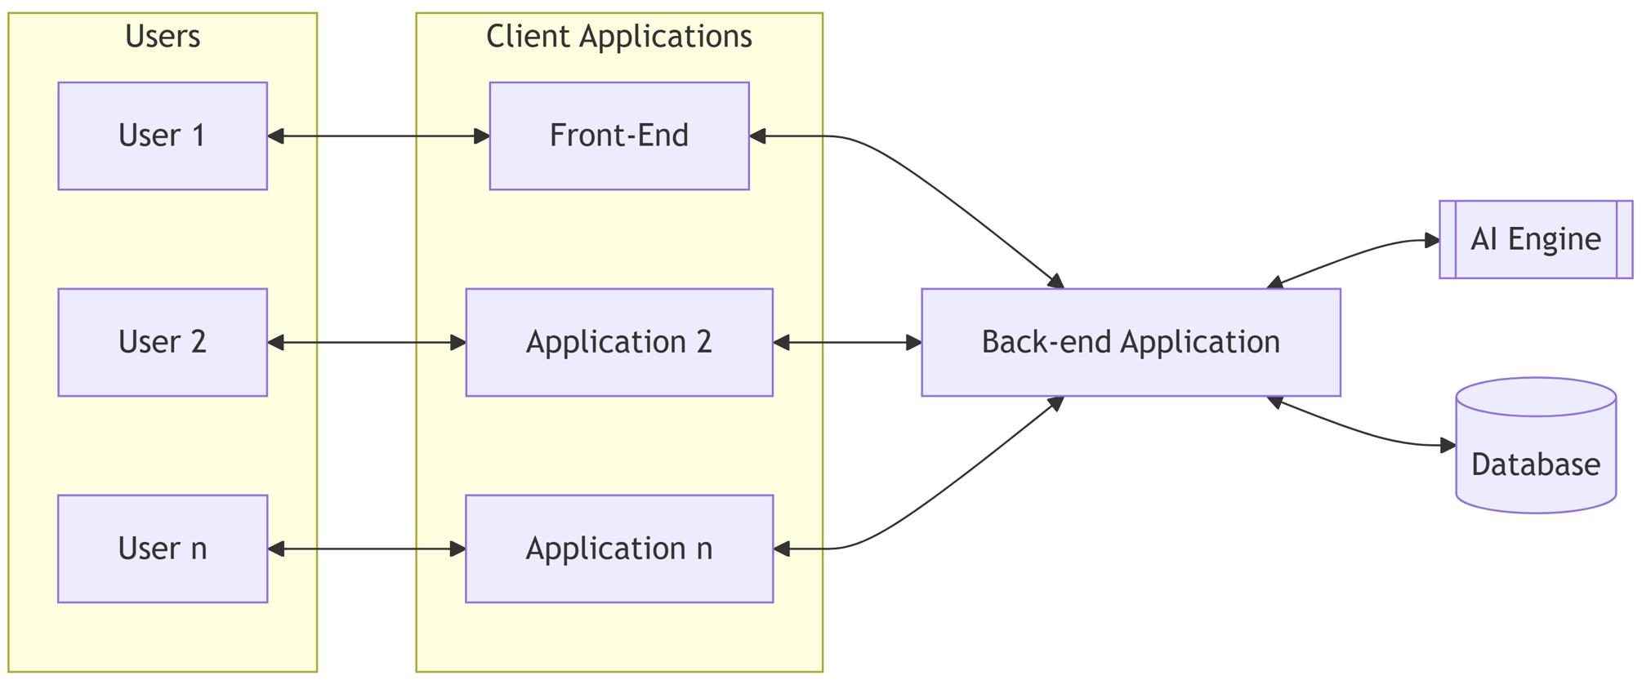
Figure 3 - High-level conceptual architecture of the artifact developed

3.4.1 – Front-end layer
It is important to clarify that the front-end layer of the solution is not addressed in this dissertation, as it falls outside the defined scope of the present research. The development of the front-end component is currently being carried out in parallel as part of a separate master’s dissertation by another researcher within the organization. This complementary work focuses on the user-facing interface and interaction layer, while the present dissertation concentrates exclusively on the design, development, and evaluation of the backend artifact and the supporting AI engine. By delineating this separation of responsibilities, the architectural design remains coherent and aligned with the objectives of the study, ensuring that each layer of the system is investigated with the appropriate depth and methodological focus.

3.4.2 – Database layer
The conceptual data model presented in Figure 4 outlines the core entities and relationships that structure the assessment artifact. It captures how clients, projects, assessments, questions and responses interact within the system, establishing the foundation for auditability, scoring and AI-driven question selection.
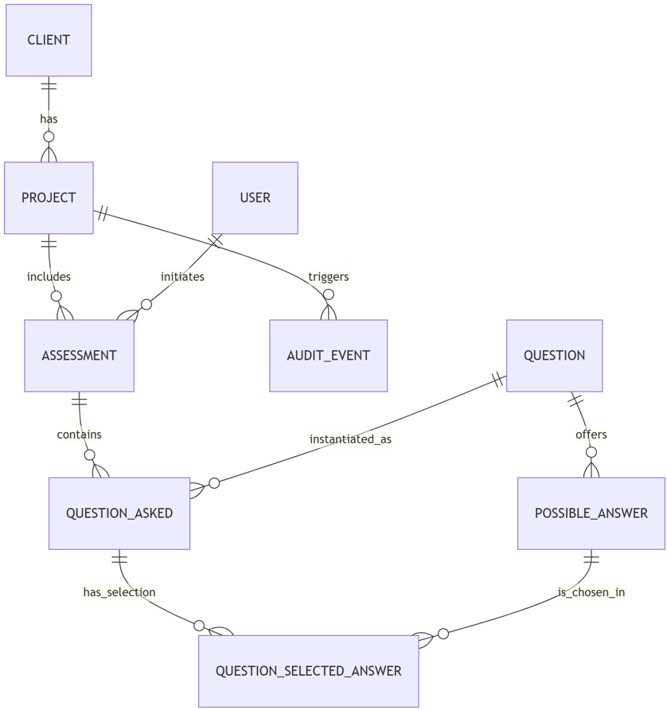
Figure 4 - Conceptual entity–relationship model supporting the assessment artifact
The CLIENT entity represents the AMS customer organization and provides the high-level organizational context within which projects and assessments are situated. By distinguishing client-level information from project-specific details, the artifact supports multi-tenant operation and enables longitudinal analysis across different customers.
Within each client, the PROJECT entity identifies the specific AMS service or application portfolio under support. As many clients operate multiple services, this entity establishes the contextual anchor for assessments, allowing the evaluation logic to adapt to service-specific characteristics such as criticality, technology stack or contractual requirements.
Interaction with the artifact is mediated through the USER entity, which identifies the individuals responsible for initiating assessments and submitting responses. This entity also underpins authentication and role-based access control, ensuring that assessment activities remain aligned with governance and accountability requirements typical of AMS environments.
An ASSESSMENT captures a single execution of the evaluation process for a given project. Each instance aggregates the set of question occurrences, the responses provided, the associated timestamps and the resulting maturity scores. Storing this information centrally enables full reconstructability of the assessment flow and supports reporting and comparison across different execution periods or across clients.
At the core of the question catalog lies the QUESTION entity, which defines the reusable templates from which assessment flows are constructed. Each question specifies its expected response type—single or multiple choice—and can be instantiated repeatedly across different assessments.
To support structured inputs, the POSSIBLE_ANSWER entity stores the predefined response options associated with each question. As the artifact does not accept free-text answers, every user response is linked to one or more of these predefined options, ensuring consistency, simplifying scoring and enabling effective interpretation by the AI-based next question logic.
During an assessment, each question presented to the user is recorded as a QUESTION_ASKED instance. This entity captures the concrete occurrence of a question, including contextual metadata such as timestamps and assessment references, allowing the system to reconstruct the exact sequence in which questions were delivered.
User selections are captured through the QUESTION_SELECTED_ANSWER entity, which links each question occurrence to the chosen option or options. Its associative structure accommodates both single-choice and multi-select responses, ensuring that input data remains normalized, traceable and ready for machine-based scoring and reasoning.
Finally, the AUDIT_EVENT entity provides a unified mechanism for recording changes and interactions across the artifact. Each event stores the user responsible, the affected entity, the action performed and relevant metadata. Centralizing audit information in this way supports traceability, reinforces governance and allows detailed analysis of assessment activity.

3.4.3 – Backend layer
In the architecture of the artifact, the backend layer plays a central role, acting as the component where all core logic of the assessment process resides. While the front-end or other client applications provide the user interface, it is the backend that interprets requests, coordinates the flow of questions, stores responses, interacts with the AI engine and ensures that every action is validated and persisted in an auditable form.
Designed as the operational backbone of the system, this layer integrates the different functional domains defined earlier — from data management and workflow orchestration to AI interaction, scoring and reporting — and exposes them in a coherent and controlled manner. By separating the business logic from both the presentation and data layers, the backend ensures a modular, maintainable and extensible structure suitable for the AMS environment in which the artifact operates.

To structure these responsibilities in a clear and modular way, the backend layer follows a layered architectural pattern inspired by the Model–View–Controller (MVC) paradigm. Although traditionally associated with user interface development, MVC provides a useful conceptual framework for separating the artifact’s core concerns: the management of domain data, the orchestration of business logic and the exposure of interaction points to external applications. By adopting this structure at a logical level, the design supports maintainability, reduces coupling between components and ensures that each functional domain is encapsulated within a well-defined part of the system.
The Model layer represents the core domain of the artifact and encapsulates the entities, relationships and repositories that manage assessment data. It includes the conceptual structures presented in the previous subsection — such as clients, projects, assessments, questions and responses — and defines how these objects are stored, retrieved and maintained throughout the system. By centralizing domain rules and persistence concerns within this layer, the artifact ensures consistency across operations and provides a stable foundation upon which higher layers can operate. The Model layer therefore implements the fundamental data-related functional domains, including assessment data management and the handling of user-submitted answers.
The Controller/Service layer contains the business logic that orchestrates the assessment process. Operating between the Model and View layers, it coordinates the lifecycle of an assessment, validates inputs, manages transitions between assessment states and integrates with external components such as the AI-based NBQ engine and the scoring engine. This layer is also responsible for enforcing role-based access permissions, recording audit events and ensuring the correct application of the functional domains defined for the artifact. By consolidating these responsibilities, the Controller/Service layer acts as the central decision-making component of the system, maintaining coherence and reliability across different use cases and client contexts.
The View layer represents the outward-facing interface through which external applications interact with the backend. Rather than a graphical interface, in this context the View layer corresponds to a set of conceptual interaction points through which client applications can initiate assessments, request questions, submit answers and retrieve results. By abstracting these interactions into a dedicated layer, the design ensures that external systems remain decoupled from the internal logic of the artifact, enabling interoperability, modularity and extensibility. This layer therefore serves as the bridge between the assessment workflow and the wider AMS ecosystem.
The overall structure of the backend layer is summarized in Figure 5, which depicts its organization following the MVC pattern and the role of each component within the assessment workflow.
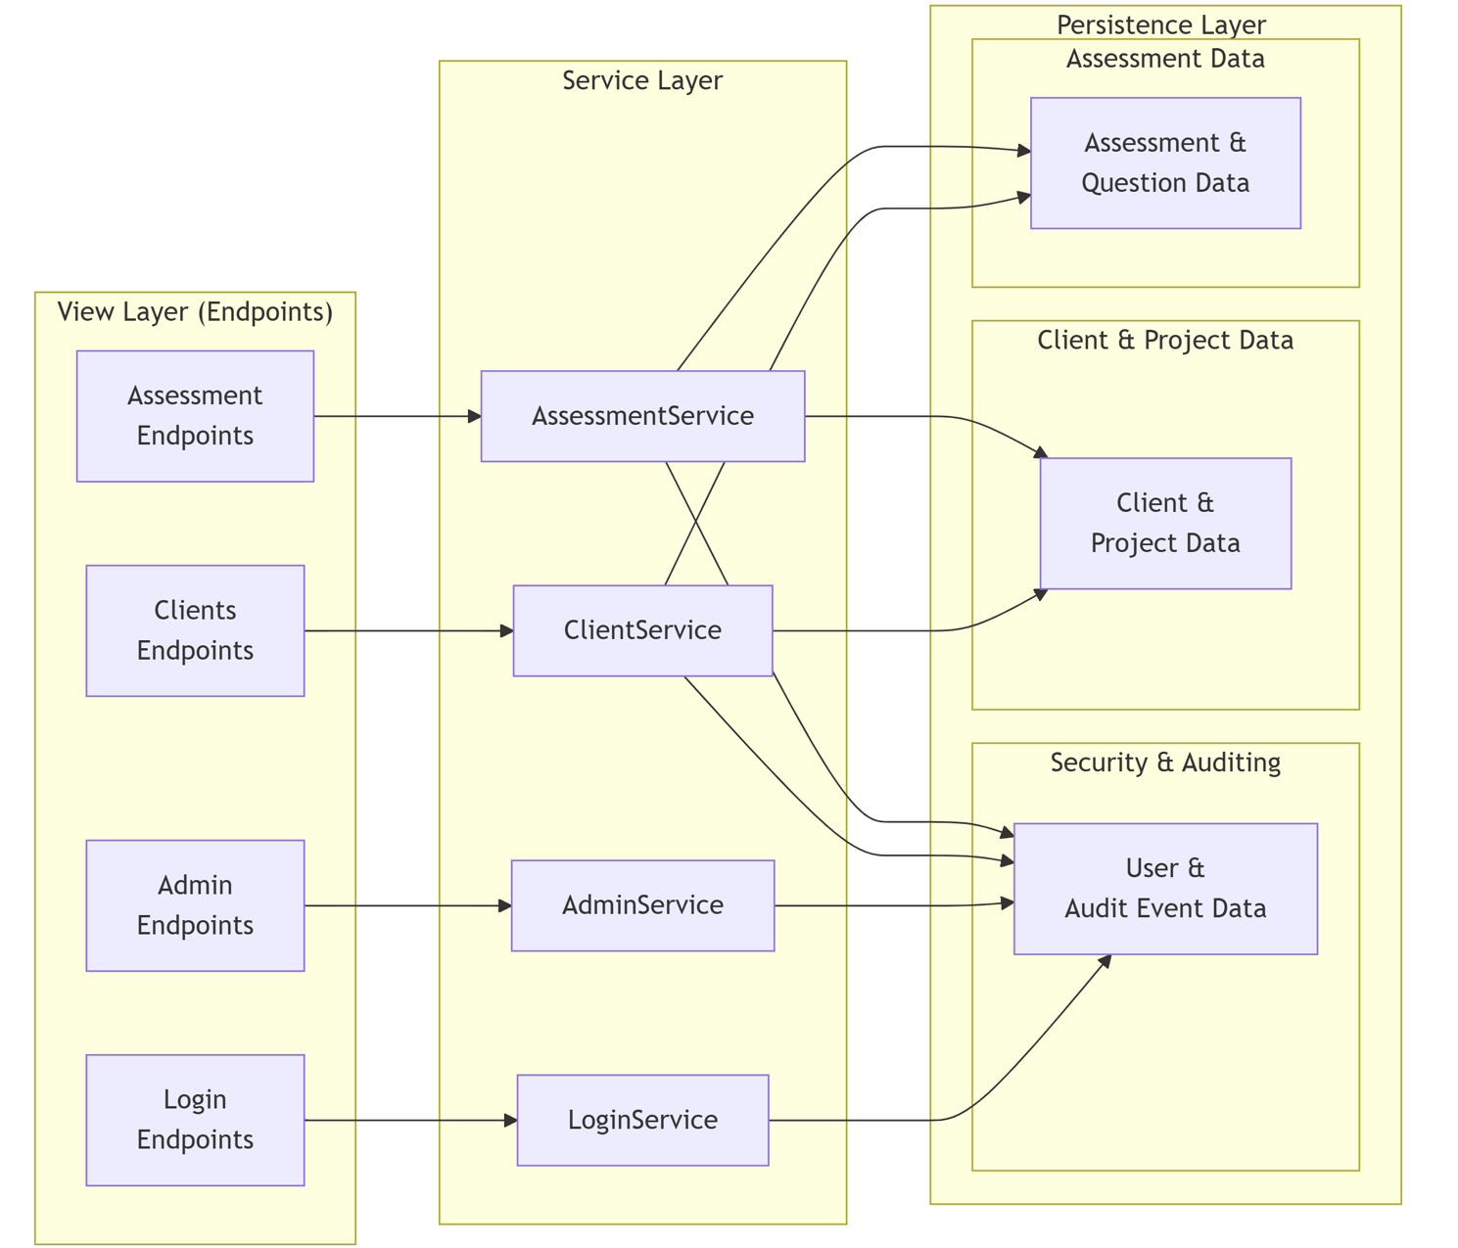
Figure 5 - Backend layer logical structure
The Login endpoint constitutes the entry point through which users authenticate before interacting with the assessment artifact. Their main responsibility is to receive authentication requests, validate incoming credentials and ensure that only authorized users can access protected backend operations. These endpoints do not contain business logic; instead, they act as a controlled interface between the client applications and the authentication mechanisms implemented in the service layer. This separation contributes to maintainability, reduces coupling between external interfaces and internal backend components, and supports the enforcement of security-related concerns. Table 7 summarizes the functional mapping of the Login endpoint, highlighting its role in authentication, access control and secure interaction with the backend service layer.

Table 7 - Functional mapping of the Login endpoint
Capability | Authentication and access control
Description | Validates user credentials and supports controlled access to protected backend operations
Related functional domains | F10 – Authentication and Roled-Based Access Control
Service layer component | LoginService
Role in the artifact | Provides authentication and access control for secure interaction with the backend.

A detailed technical specification of this endpoint is provided in Appendix A, Table X.
The Administration endpoints provide the interface through which authorized administrative users manage the configuration and governance aspects of the artifact, particularly the creation and maintenance of user accounts and their associated roles. These endpoints serve as controlled access points for operations such as registering new users, updating role assignments and modifying account status, ensuring that only users with the appropriate administrative privileges can perform such actions. As with other elements of the View layer, the Admin endpoints do not contain business logic themselves; instead, they validate incoming requests, enforce security and RBAC constraints, and delegate the execution of administrative actions to the corresponding service component. This separation maintains the integrity of the system while supporting compliance, auditability and operational governance within the AMS environment. Table 8 summarizes the functional mapping of the Administration endpoints, showing how they support user management, role-based access control, auditability and operational governance within the assessment artifact.

Table 8 - Functional mapping of the Administration endpoints
Capability | User administration and governance support
Description | Supports administrative operations related to the creation, maintenance and governance of user accounts, roles and account status.
Related functional domains | F7 – Auditability and Logging;  F10 – Authentication and Role-Based Access Control
Service layer component | AdminService
Role in the artifact | Provides controlled administrative capabilities that support user management, role-based access control, auditability and operational governance of the assessment artifact.

A detailed technical specification of the Administration endpoints is provided in Appendix A, Tables A.X to A.X.
The Clients endpoints provide the interface through which authorized users access and manage the organizational context required for the assessment process, namely clients and their associated application portfolios. These endpoints support operations such as retrieving registered clients, viewing detailed client information and, when permitted, creating or updating client records. As part of the View Layer, their primary role is to validate incoming requests, enforce authentication and role-based access constraints, and delegate the execution of client-related business rules to the ClientService. By centralizing client-related interactions within this endpoint group, the system ensures a clear separation of concerns, maintains consistency across the user interface and guarantees that contextual data used by the assessment workflow remains accurate, traceable and securely managed. Table 9 summarizes the functional mapping of the Clients endpoints, showing how they support client and project metadata management within the assessment artifact.

Table 9 - Functional mapping of the Clients endpoints
Capability | Client and project metadata management
Description | Supports the consultation, creation and maintenance of client-related information required to contextualize the assessment process, including clients, projects and associated application portfolios.
Related functional domains | F9 – Client-specific Contextual Adaptation; F11 – Client and Project Metadata Capture
Service layer component | ClientService
Role in the artifact | Provides access to the contextual data required to initialize and adapt assessments, ensuring that client and project information remains consistent, traceable and securely managed.

A detailed technical specification of the Clients’ endpoints is provided in Appendix A, Tables A.X to A.X.
The Assessment endpoints constitute the primary interaction interface through which users initiate and conduct the assessment process. They expose operations such as starting a new assessment, retrieving the next question in the sequence, submitting selected answers and accessing the resulting maturity scores or reports. As part of the View Layer, these endpoints are responsible for receiving and validating external requests, ensuring that they follow the expected structure and that the caller has the necessary permissions to perform the requested action. The endpoints themselves do not implement assessment logic; instead, they delegate workflow coordination, question sequencing, scoring interactions and data manipulation to the AssessmentService. This design preserves a clear separation of concerns, maintains consistency across the assessment workflow and enables external applications to interact with the artifact in a controlled and predictable manner. Table 10 summarizes the functional mapping of the Assessment endpoints, highlighting their role in orchestrating the assessment workflow, collecting answers, supporting scoring and enabling controlled interaction with the backend service layer.

Table 10 - Functional mapping of the Assessment endpoints
Capability | Assessment workflow execution and data management
Description | Supports the execution of the assessment process, including assessment initiation, question retrieval, answer submission, workflow progression and access to maturity scores or reports.
Related functional domains | F1 – Assessment Data Management;  F2 – Answer Collection and Submission Handling;  F3 – Scoring and Maturity Evaluation Engine;  F4 – AI-Based Next Question Engine;  F5 – Assessment Workflow Orchestration; F8 – Reporting and Output Generation;  F9 – Client-specific Contextual Adaptation
Service layer component | AssessmentService
Role in the artifact | Provides access to the contextual data required to initialize and adapt assessments, ensuring that client and project information remains consistent, traceable and securely managed.
A detailed technical specification of the Assessment endpoints is provided in Appendix A, Tables A.X to A.X.

3.4.4 – The AI engine
The AI Engine constitutes the intelligent component of the proposed artifact and is responsible for enhancing the assessment process through adaptive decision support and automated evaluation mechanisms. While the backend layer orchestrates the workflow and manages the persistence of assessment data, the AI Engine introduces a layer of analytical reasoning that enables the system to dynamically adapt the assessment process and to derive meaningful evaluation outcomes from the collected responses.
Within the context of AMS, assessments related to Business Continuity and Change Management frequently involve complex operational environments where the relevance of specific questions may vary depending on the characteristics of the client, the service context and the responses already provided. Traditional static questionnaires often fail to capture these contextual nuances, leading to rigid evaluation processes that may overlook important aspects of operational maturity. The AI Engine addresses this limitation by introducing adaptive mechanisms that guide the assessment flow and support the interpretation of the collected data.
From an architectural perspective, the AI Engine operates as a specialized component invoked by the backend service layer during the execution of an assessment session. It processes contextual information, previously recorded answers and predefined evaluation rules to assist the system in selecting relevant questions and in translating qualitative inputs into structured maturity indicators.
To support these capabilities, the AI Engine is organized into two main functional modules. The first module, referred to as the NBQ Engine, determines which question should be presented next during the assessment process by analyzing the current state of the session and the answers previously submitted. The second module, the Scoring Engine, is responsible for computing maturity levels and readiness indicators based on the responses collected throughout the assessment.
Together, these components provide the analytical core of the artifact, enabling the system to deliver adaptive assessments and consistent evaluation outcomes while maintaining alignment with the operational requirements of AMS environments.
NBQ Engine
The NBQ Engine is responsible for determining which question should be presented next during the execution of an assessment session. Instead of relying on a static questionnaire in which questions are asked in a fixed order, the proposed system adopts an adaptive assessment approach in which the sequence of questions is dynamically determined according to the current state of the evaluation.
To support structured and consistent assessments within the domains of Business Continuity and Change Management, the questions used by the system are organized into predefined thematic topics representing key operational capabilities that organizations must demonstrate to ensure resilience and effective change governance.
The assessment framework adopted in this study is structured around a set of predefined thematic topics that represent key operational capabilities within each assessment domain. These topics are used to organize the assessment questions and to ensure that the evaluation covers the most relevant dimensions of organizational practices.
Two main assessment domains are considered in this research: Business Continuity and Change Management. Each domain is decomposed into a few topics that represent critical operational areas to be evaluated during the assessment process. The topics considered for each domain are presented in Tables 11 and 12.
Table 11 - Business Continuity assessment topics
Business continuity topic | Explanation
Risk identification | Evaluation of the organization’s ability to identify critical risks that may disrupt business operations.
Impact analysis | Assessment of whether the organization analyzes the potential operational and financial impacts of service disruptions.
Recovery strategy | Evaluation of the strategies defined to restore critical services after a disruption or incident.
Backup and redundancy | Assessment of the mechanisms implemented to ensure data protection and system availability through backup and redundancy solutions.
Incident response | Evaluation of the procedures and organizational capabilities established to respond effectively to disruptive incidents.
Testing and Training | Assessment of whether business continuity plans are regularly tested and whether personnel receive appropriate training.
Table 12 - Change management assessment topics
Change management topic | Explanation
Change governance | Evaluation of the organizational structures and policies that govern the management of changes.
Change approval process | Assessment of the procedures used to review, approve, and authorize changes before implementation.
Impact analysis | Evaluation of whether potential technical and operational impacts of changes are systematically analyzed.
Communication | Assessment of how changes are communicated to stakeholders and operational teams.
Rollback procedures | Evaluation of the existence of fallback or rollback mechanisms in case a change fails or produces unexpected effects.
Post-implementation review | Assessment of whether implemented changes are reviewed to evaluate their outcomes and identify improvement opportunities.

Each topic is associated with a set of predefined assessment questions that aim to progressively evaluate the maturity of the organization in that specific area. Due to confidentiality constraints associated with the industrial context in which this research was conducted, the complete list of questions cannot be disclosed in this document. However, Tables 13 and 14 present a small number of illustrative examples of questions used within the assessment framework.
Table 13 - Example 1 of an assessment question
Q1: Has the organization integrated critical external partners into the continuity planning process?
0 | No effort nor recognition of need to identify potential partnerships within the community as it relates to continuity.
1
2 | The organization conducted preliminary efforts to identify community partnerships that have been made.
3
4 | The organization met with critical community partners and discussed ways to incorporate them into the continuity program, but no official activities have taken place.
5
6
7
8 | The organization integrated most, but not all, of the identified critical community partners into the organization's continuity planning effort.
9
10 | The organization integrated critical community partners into the continuity planning effort. These partners are active participants in continuity program activities.
Table 14 - Example 2 of an assessment question
Q2: Has the organization identified and prioritized the essential functions that it must continue to perform during a continuity event?
0 | No effort nor recognition of need for identifying and prioritizing essential organizational functions.
1
2 | The organization made preliminary efforts to identify organizational essential functions but has not created a formal list.
3
4 | The organization identified essential organizational functions but has not prioritized these functions.
5
6
7
8 | The organization identified and prioritized essential organizational functions, although some areas for improvement remain. The organization has continued planning to fully address.
9
10 | The organization identified, prioritized, and adopted organizational essential functions and incorporated these functions into the continuity plan.

During the execution of an assessment, the NBQ engine analyzes the questions already answered, the topics that have been evaluated, and the contextual characteristics of the assessment, such as the type of evaluation being conducted and the industry of the client organization. Based on this information, the engine selects the next most relevant question from the available knowledge base, ensuring that all relevant topics are covered while avoiding redundant or unnecessary questions.
This adaptive selection process allows the assessment to remain both comprehensive and efficient, enabling the system to gather sufficient information to evaluate organizational maturity while minimizing the number of questions required during the evaluation process.
To dynamically determine the next question to be presented during the assessment process, the system implements a structured selection workflow within the NBQ engine. This workflow evaluates the current state of the assessment, identifies topics that have not yet been sufficiently explored, and selects the most relevant question to continue the evaluation process. The sequence of operations performed by the NBQ engine is illustrated in Figure 6.
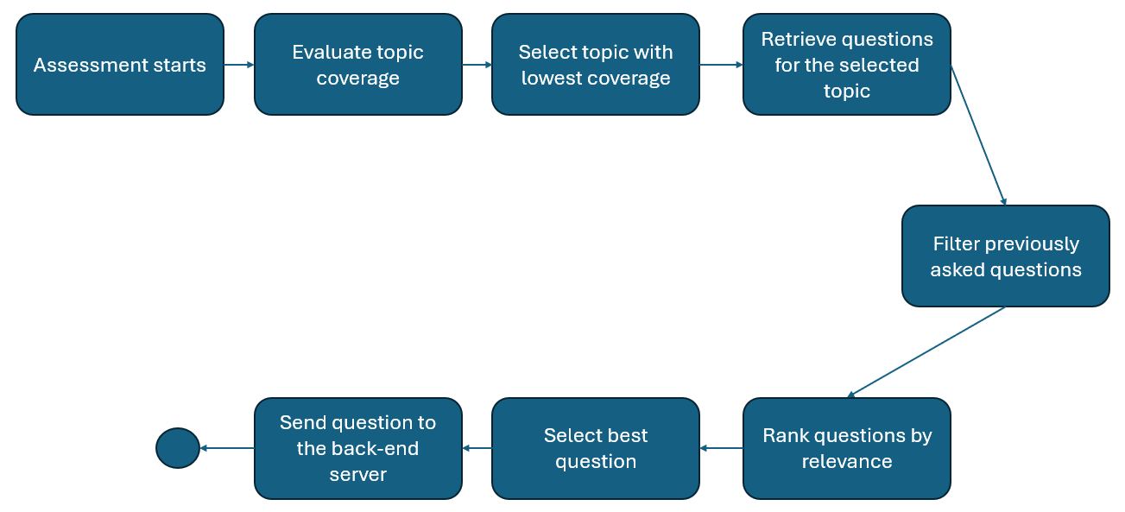
Figure 6 - NBQ selection workflow
The process begins with the evaluation of topic coverage within the current assessment session. The system identifies which topics have received the least coverage and prioritizes them to ensure that all relevant assessment dimensions are evaluated. Once a topic is selected, the engine retrieves the set of candidate questions associated with that topic and filters questions that have already been presented earlier in the session. The remaining questions are ranked according to their relevance based on contextual factors and previous answers provided by the user. Finally, the highest ranked question is selected and returned to the assessment workflow to be presented to the user.
A minimum number of questions is required for each topic before the system evaluates the stability of the maturity estimate. This ensures that the assessment is based on sufficient information. The system evaluates the consistency of the answers collected for a given topic. When the responses indicate a stable maturity level, the system considers that sufficient information has been gathered to evaluate that topic.
In addition to the minimum coverage requirement and stability evaluation, the system also enforces a maximum number of questions per topic. This constraint ensures that the assessment process remains efficient and avoids excessive questioning in cases where the maturity level cannot be determined with complete certainty. Once the maximum number of questions for a given topic has been reached, the system concludes the evaluation of that topic and proceeds to another domain.
Furthermore, the NBQ engine considers the relevance of the remaining candidate questions. Based on the answers previously provided by the user and the contextual characteristics of the assessment, certain questions may no longer be applicable or may provide limited additional value. In such cases, if no relevant questions remain for a given topic, the system considers that topic sufficiently evaluated and moves forward in the assessment process.
To support the decision-making process, the system maintains an internal notion of confidence regarding the estimated maturity level of each topic. This confidence is derived from both the number of answers collected and the consistency of those answers. As more responses are gathered and the observed maturity pattern becomes clearer, the confidence level increases. When a sufficient level of confidence is reached, the system determines that additional questions are unlikely to significantly improve the accuracy of the evaluation.
Overall, the evaluation of each topic is governed by a combination of complementary stopping criteria, including minimum coverage, stability of responses, maximum question limits, and confidence in the maturity estimation. This hybrid approach enables the assessment process to remain both adaptive and efficient, ensuring comprehensive coverage of all relevant topics while minimizing unnecessary interaction with the user.
The stopping criteria applied by the NBQ engine are summarized in Table 15.

Table 15 - Stopping criteria for topic evaluation
Criterion | Description | Purpose
Minimum coverage | A minimum number of questions must be answered before the system evaluates the maturity of a topic. | Ensures that the evaluation is based on sufficient information.
Maturity stability | The system evaluates whether the answers collected for a topic are consistent and indicate a clear maturity level. | Prevents unnecessary questioning once a stable maturity estimate is reached.
Maximum number of questions | Each topic has a predefined maximum number of questions that can be asked. | Limits the duration of the assessment and avoids excessive questioning.
Question relevance | The system filters out questions that are no longer relevant based on previous answers and context. | Ensures that only meaningful questions are asked during the assessment.
Confidence level | The system estimates confidence in the maturity evaluation based on the number and consistency of answers. | Determines whether sufficient certainty has been achieved to conclude the topic evaluation.

These criteria are applied jointly to determine when a topic has been sufficiently evaluated. The combination of these mechanisms allows the system to balance assessment completeness with efficiency.
The Scoring Engine is responsible for transforming the answers collected during the assessment into measurable maturity and readiness indicators. While the NBQ Engine determines which question should be presented next, the Scoring Engine interprets the answers already provided and converts them into structured evaluation outputs. This component is therefore essential to ensure that the assessment does not remain merely descriptive, but produces comparable and actionable results for Business Continuity and Change Management analysis.
Each predefined answer option is associated with a maturity value, typically represented on a numerical scale from 0 to 10. Lower values indicate limited awareness, absence of formal practices, or weak implementation, while higher values represent more structured, documented, tested, and continuously improved practices. By associating each possible answer with a numerical value, the system ensures that qualitative responses can be consistently translated into quantitative indicators.
The scoring process is performed at topic level. For each assessment topic, such as risk identification, impact analysis, recovery strategy, change governance, or rollback procedures, the engine aggregates the values of the answers provided to the questions associated with that topic. This allows the system to estimate the maturity level of each individual topic rather than producing only a single global score. Topic-level scoring is particularly relevant because an organization may demonstrate strong maturity in one area while still presenting weaknesses in another.
Once topic-level scores are calculated, the Scoring Engine derives an overall assessment result by aggregating the maturity values across the topics included in the selected assessment domain. Depending on the configuration of the assessment, this aggregation may follow a simple average or a weighted approach, where some topics receive greater importance due to their relevance to the client context, service criticality, or governance requirements. This enables the assessment to remain adaptable while preserving consistency in the scoring process.
In addition to calculating maturity values, the Scoring Engine also contributes to the adaptive behavior of the assessment. Partial scores obtained during the assessment can be used by the NBQ Engine to identify topics where maturity remains unclear, inconsistent, or insufficiently explored. For example, if the answers collected for a given topic suggest divergent maturity levels, the system may assign lower confidence to that topic and request additional questions before closing its evaluation. In this way, the Scoring Engine and the NBQ Engine operate together: the former evaluates the current maturity state, while the latter uses that information to decide whether further evidence is required.
The final output of the Scoring Engine includes the maturity score for each topic, the global maturity or readiness score, and supporting indicators that may help interpret the result. These outputs can then be used by the reporting component to generate assessment summaries, identify weaker areas, and support decision-making within AMS environments.
The relevance ranking of candidate questions may be supported by a Large Language Model. After the deterministic filtering stage, the backend constructs a structured prompt containing the client and project context, the assessment domain, the selected topic, the questions already presented, the answers previously submitted, the current maturity estimate and the remaining candidate questions. The LLM is then requested to identify which candidate question is most likely to reduce uncertainty and provide additional evidence regarding the maturity of the selected topic. The model does not generate new questions; instead, it selects one question from the predefined candidate set and returns its identifier together with a relevance score and a brief justification. The backend validates the returned identifier before presenting the question to the user, ensuring that the selection remains constrained, auditable and aligned with the predefined assessment framework.

Chapter 4

Results and discussion
This chapter presents and discusses the results obtained during the evaluation of the proposed AMS Assessment Tool, with particular focus on the backend artifact developed in this research. Building on the methodological approach described in Chapter 3, the evaluation was conducted according to the Design Science Research methodology, through two iterative validation cycles involving experienced AMS professionals. Each iteration aimed to assess the relevance, clarity, usefulness and practical suitability of the artifact in supporting the early evaluation of application readiness within AMS transition and onboarding contexts.
The results reported in this chapter are derived from expert feedback collected through structured questionnaires. The first iteration focused on validating the initial version of the proposed functionalities, including the assessment workflow, answer collection, maturity scoring, AI-supported next-question logic, role management and integration capabilities. Based on the findings of this first cycle, improvement opportunities were identified and used to refine the artifact before the second iteration. The second iteration then allowed for the reassessment of the revised solution and the validation of whether the proposed changes addressed the limitations and suggestions identified by participants.
The discussion presented in this chapter interprets the evaluation findings in relation to the research objectives, the problem identified in the AMS onboarding context, and the design decisions adopted during the development of the artifact. Attention is given to how the proposed backend supports the assessment of Business Continuity and Change Management readiness, structures the collection and processing of assessment data, and promotes greater traceability and consistency in early project evaluation processes. The chapter therefore aims to show how expert feedback contributed to validating and refining the artifact across the two DSR iterations.

  - Overview of Evaluation results
This section provides an overview of the evaluation results obtained during the validation of the proposed AMS Assessment Tool. As described in Chapter 3, the evaluation followed an iterative Design Science Research approach, in which expert feedback was used not only to assess the artifact, but also to guide its refinement across successive development cycles.
The evaluation was organized into two iterations involving experienced professionals from AMS-related contexts. The first iteration focused on the initial version of the artifact and aimed to assess the relevance, clarity, usefulness and practical suitability of its main functional areas. These included assessment workflow, answer collection and submission handling, maturity and risk scoring, AI-supported next-question logic, auditability, role-based access control, client-specific contextualization and integration capabilities. The results of this iteration provided evidence regarding the strengths of the proposed solution, while also identifying aspects requiring clarification, adjustment or further development.
Based on the findings collected during the first iteration, a set of improvements was defined and incorporated into the artifact. These refinements addressed issues related to the presentation of assessment results, the explainability of questions and scoring outcomes, the flexibility of the assessment flow, and the alignment of the solution with practical AMS onboarding needs. The second iteration then focused on validating the updated version of the artifact, assessing whether the proposed changes responded adequately to the feedback previously collected.
Across both iterations, the evaluation results are interpreted from a professional practice perspective. Rather than being treated as isolated questionnaire outcomes, the findings are analyzed as part of an iterative validation process in which expert judgment contributed to the progressive improvement of the artifact. The following sections therefore present the results of each iteration, discuss the feedback received, and relate the findings to the research objectives and to the design principles underlying the AMS Assessment Tool.
  - First Evaluation Iteration
The first evaluation iteration included 16 responses collected through a structured questionnaire addressed to professionals with experience in IT, AMS, service management, Business Continuity, Change Management, or assessment-related activities. The closed-ended questions were analyzed using descriptive statistics, including mean values, median values, standard deviation and the percentage of positive responses, defined as ratings of 4 or 5 on the five-point scale. Open-ended responses were analyzed thematically to identify recurring suggestions, concerns and improvement opportunities.
Before presenting the results of the first evaluation iteration, it is important to characterize the respondents who participated in the validation process. Since the evaluation relied on expert judgment, the professional background and experience of the participants provide relevant context for interpreting the results obtained. Table 16 summarizes the profile of the respondents, including their professional experience and their familiarity with areas related to the scope of the artifact, such as Business Continuity, Change Management, assessment, audit and AMS-related activities.

Table 16 - Characterization of first-iteration respondents
Dimension | Category | Number of participants | Percentage
Professional experience | 3-5 years | 2 | 12.5%
 | 6-10 years | 6 | 37.5%
 | More than 10 years | 8 | 50.0%
Experience with BC or CM | Yes | 12 | 75.0%
 | No | 4 | 25.0%
Experience with assessment, audit or evaluation activities | Yes | 11 | 68.75%
 | No | 5 | 31.25%
As shown in Table 16, the respondents involved in the first evaluation iteration had a relevant level of professional experience. Half of the participants reported more than ten years of professional experience, while 37.5% had between six and ten years of experience. This indicates that the feedback collected was largely supported by professionals with significant exposure to IT and AMS-related contexts. In addition, 75.0% of the respondents reported experience with Business Continuity or Change Management, and 68.75% had previous involvement in assessment, audit or evaluation-related activities. These results strengthen the relevance of the first iteration findings, as the participants were able to assess the proposed artifact from perspectives directly aligned with its main objectives: supporting structured AMS assessments, improving traceability, and contributing to more informed readiness evaluation processes.
In addition to professional experience, the respondents were also characterized according to their professional role or profile. This dimension is relevant because the artifact under evaluation addresses different concerns within AMS contexts, including technical implementation, service delivery, governance, assessment and decision support. As shown in Figure 7, the participants represented a diverse set of professional profiles, allowing the first evaluation iteration to capture perspectives from both technical and management-oriented roles.

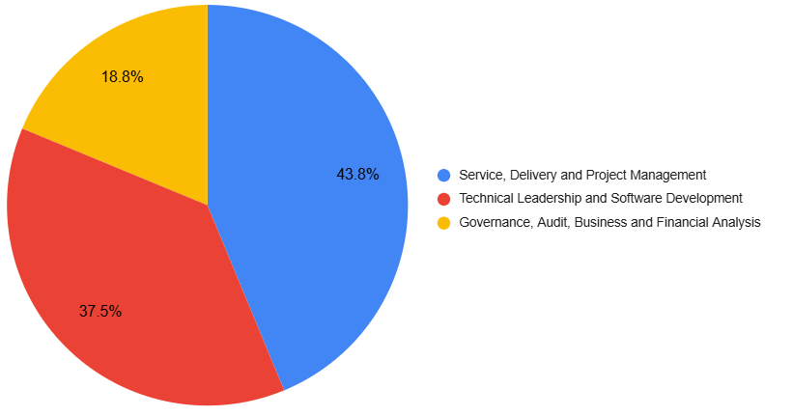
Figure 7 - Distribution of respondents by professional role group
To improve readability, individual job titles were grouped into broader professional role categories. The Service, Delivery and Project Management category includes roles such as Delivery Lead, Service Manager, Director Consulting Delivery and Project Manager. The Technical Leadership and Software Development category includes roles such as Tech Lead, Architect and Developer. Finally, the Governance, Audit, Business and Financial Analysis category includes roles such as Audit Director, Business Analyst and FP&A Director. This grouping makes it possible to present the respondents’ professional background in a concise way while preserving the main perspectives represented in the sample.
The first evaluation iteration was conducted through structured interviews supported by a questionnaire. This format ensured that all participants evaluated the same functional areas of the artifact and answered the same set of closed-ended and open-ended questions, allowing consistency in the collection and comparison of feedback. At the same time, the interview setting allowed participants to clarify their reasoning, provide additional comments and discuss improvement opportunities beyond the predefined questions.
The interviews were conducted in two formats: in person and remotely, depending on participant availability and logistical constraints. Although the format varied, the structure of the evaluation remained the same across all sessions, since the questionnaire was used as the common basis for data collection. This approach made it possible to combine flexibility in the execution of the interviews with consistency in the evaluation process. Table 17 presents the distribution of evaluation sessions by format.

Table 17 - Distribution of evaluation sessions by format (1st iteration)
Format | Number of participants | Percentage
In person | 9 | 56.25%
Remote | 7 | 43.75%
The use of both in-person and remote formats provided flexibility in the execution of the first evaluation iteration without changing the structure of the evaluation process. Since all sessions were supported by the same questionnaire and covered the same functional areas, the variation in format did not affect the consistency of the data collection procedure.
Before evaluating the specific functional areas of the artifact, the questionnaire included two general statements intended to assess participants’ perception of the overall assessment approach proposed in this research. These statements focused on two core assumptions underlying the artifact: first, that a structured and standardized assessment process can improve consistency across different clients or projects; and second, that AI-supported adaptive questionnaires can make the assessment process more efficient and relevant than fully static questionnaires. These results provide an initial indication of whether participants recognized the broader relevance of the proposed solution before assessing its individual functionalities.
The closed-ended responses were analyzed using a five-point Likert scale. To calculate the mean score, each response option was converted into a numerical value, where 1 corresponded to “Strongly disagree”, 2 to “Disagree”, 3 to “Neutral”, 4 to “Agree” and 5 to “Strongly agree”. The mean score therefore represents the average level of agreement with each statement. Positive responses were defined as responses rated 4 or 5, corresponding to “Agree” and “Strongly agree”.
To provide an initial overview of participants’ perception of the proposed assessment approach, Table 18 presents the results obtained for the two general statements related to assessment standardization and AI-supported adaptability.
Table 18 - General perception of the proposed assessment approach
Statement | Positive responses | Mean score (1 to 5)
A structured and standardized approach can improve assessment consistency across clients or projects. | 93.8% | 4.63
AI-supported adaptive questionnaires can make assessments more efficient and relevant than static questionnaires. | 100.0% | 4.50

As shown in Table 18, both general statements received highly positive evaluations, indicating that participants recognized the relevance of the proposed assessment approach. The first statement obtained 93.8% positive responses and a mean score of 4.63, suggesting strong agreement with the idea that a structured and standardized approach can improve consistency across assessments performed for different clients or projects. This result supports one of the main motivations of the artifact: reducing ambiguity and promoting a more uniform basis for collecting, processing and interpreting assessment information in AMS contexts. The second statement obtained 100.0% positive responses and a mean score of 4.50, showing that all respondents agreed or strongly agreed with the potential value of AI-supported adaptive questionnaires. This finding reinforces the relevance of including adaptive logic in the proposed backend artifact, particularly in AMS onboarding contexts where client characteristics, application criticality and project conditions may vary significantly.
Before presenting the aggregated results, it is important to clarify the scope of each functional area evaluated in the first iteration. Each area corresponds to a group of questionnaire items designed to assess a specific aspect of the proposed artifact, ranging from the overall relevance of the solution to the clarity of the assessment workflow, scoring mechanisms, AI-supported questioning, traceability and integration capabilities. Table 19 summarizes the dimensions evaluated in each functional area.
Table 19 - Functional areas evaluated in the first iteration
Functional area | Evaluated aspects
Workflow control | Clarity of the assessment flow, ability to guide users through the assessment process, and suitability of the workflow for AMS onboarding scenarios.
Scoring and results | Clarity, usefulness and interpretability of maturity/risk scores, including the presentation of results by domain or topic.
AI/NBQ explainability | Perceived usefulness of AI-supported adaptive questioning, clarity of the next-question mechanism, and need for explanations regarding question selection.
Data management and traceability | Ability to store, organize and trace assessment data, including answers, decisions, historical records and audit-related information.
Change Management topics | Relevance and adequacy of the Business Continuity topics included in the assessment scope.
Context adaptation | Relevance and adequacy of the Change Management topics included in the assessment scope.
Integration Capabilities | Perceived relevance and clarity of integrating the backend with external systems, tools or consuming interfaces.
To complement the aggregated evaluation results, the functional areas were analyzed using two indicators: the percentage of positive responses and the mean score. The first indicator shows the proportion of responses rated as 4 or 5 on the five-point Likert scale, while the second represents the average level of agreement obtained by each functional area. Figures 8 and 9 present these two indicators separately, allowing the results to be interpreted without combining different measurement scales in a single chart.

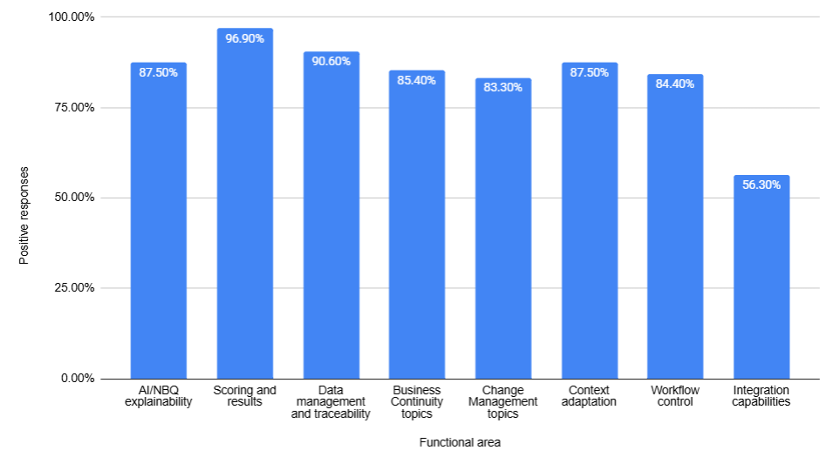
Figure 8 - Positive responses by functional area in the first evaluation iteration
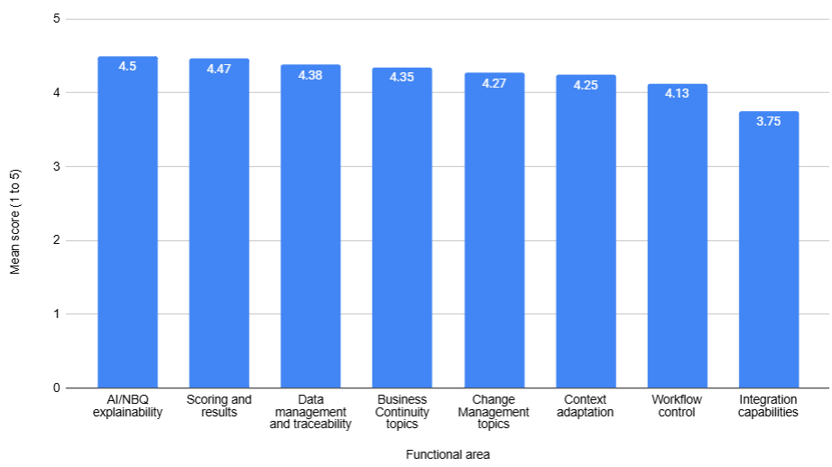
Figure 9 - Mean score by functional area in the first evaluation iteration
The results presented in Figures 8 and 9 show a generally positive evaluation of the artifact’s specific functional areas. Most dimensions obtained mean scores above 4.0 and positive response rates above 80%, indicating that respondents perceived the proposed functionalities as relevant and suitable for the AMS assessment context. This suggests that the first iteration provided initial validation for the main functional scope of the artifact, particularly regarding its ability to support structured assessment, result interpretation, traceability and contextual adaptation.
The strongest results were observed in scoring and results, which obtained 96.9% positive responses and a mean score of 4.47, and in data management and traceability, with 90.6% positive responses and a mean score of 4.38. These findings suggest that participants valued the artifact’s ability to present assessment outcomes in an understandable way and to support the storage, organization and traceability of assessment data. AI/NBQ explainability also received a high mean score of 4.50, with 87.5% positive responses, reinforcing the perceived relevance of providing clarity around the adaptive question mechanism.
Business Continuity topics, Change Management topics, context adaptation and workflow control also received favorable evaluations, with positive response rates between 83.3% and 87.5% and mean scores above 4.0. These results indicate that respondents considered the selected assessment domains and workflow structure adequate for the intended AMS onboarding and readiness evaluation context. The positive evaluation of context adaptation is particularly relevant, as it suggests that participants recognized the need for the artifact to accommodate differences between clients, applications and project conditions.
Integration capabilities represented the lowest-rated functional area, with 56.3% positive responses and a mean score of 3.75. Although this result does not indicate rejection of the functionality, it suggests a lower level of consensus among participants regarding its clarity, scope or practical implementation. This finding points to the need for further refinement in the second iteration, particularly by clarifying which external systems or consuming interfaces the backend should integrate with and how such integrations would support the overall assessment process.
After analyzing the closed-ended responses, the open-ended answers were examined to identify recurring comments, suggestions and concerns raised by participants during the first iteration. This qualitative analysis complements the quantitative results by providing additional context regarding the aspects that were perceived as valuable, unclear or requiring refinement. The responses were grouped into thematic categories, allowing the main improvement opportunities to be identified and later considered in the refinement of the artifact for the second iteration. Table 20 summarizes the main themes identified in the open-ended responses, together with a brief description of the feedback received and its implication for the refinement of the artifact.
Table 20 - Main themes identified in the open-ended responses
Theme | Summary of feedback | Implication for artifact refinement
Integration with external systems | Need to clarify target systems, tools and interoperability scenarios. | Define integration scope and priority systems.
AI/NBQ explainability | Need to explain why questions are selected and how previous answers influence the assessment path. | Improve explanations for adaptive question selection.
Result interpretation and reporting | Scores should be easier to interpret and supported by dashboards, reports or export formats. | Refine score explanations and reporting outputs.
Context adaptation | Assessment should consider client, application, project and operational context. | Strengthen contextual parameters in the assessment flow.
Assessment topic refinement | Participants suggested expanding the BC and CM topic catalog. | Review and refine the topic catalog.
The first theme identified in the open-ended responses was integration with external systems. Although the quantitative results already indicated that integration capabilities were the least strongly validated area, the qualitative feedback helped clarify the nature of this limitation. Participants did not necessarily question the relevance of integration but rather pointed to the need for a clearer definition of its scope. In particular, the feedback suggested that the artifact should specify which systems, tools or consuming interfaces are expected to interact with the backend, such as reporting tools, ITSM platforms, operational systems or front-end applications. This indicates that the integration layer should be further refined by identifying priority integration scenarios and explaining how external interoperability contributes to the overall assessment process.
AI/NBQ explainability was also highlighted as an important area for refinement. Participants recognized the potential value of adaptive questionnaires but emphasized that the selection of questions should be transparent to users. In an AMS assessment context, where answers may influence the direction of the questionnaire and potentially affect maturity or readiness conclusions, the adaptive mechanism should not be perceived as a black box. The feedback therefore suggests the need to explain why specific questions are selected, how previous answers influence the next-question logic, and how the adaptive path contributes to a more relevant assessment. This finding supports the inclusion of clearer explanatory mechanisms in the artifact, particularly at the level of question sequencing and assessment rationale.
Result interpretation and reporting emerged as another relevant theme. While the quantitative results showed strong support for scoring and results, the open-ended feedback indicated that participants expected assessment outputs to be easy to interpret and actionable. This means that scores should not be presented only as numerical values, but should be accompanied by explanatory descriptions, maturity or risk interpretation, and reporting mechanisms suitable for different stakeholders. Suggestions such as dashboards, executive summaries, detailed reports, charts and exportable formats indicate that the artifact should support both high-level decision-making and more detailed operational analysis. This finding reinforces the need to refine the way results are presented and communicated.
Context adaptation was also identified as a recurring concern. Participants noted that AMS assessments are highly dependent on the characteristics of the client, the application, the project and the operational environment. Factors such as application criticality, project complexity, team maturity, available documentation, dependencies and service context may influence how assessment results should be interpreted. This feedback supports the need to strengthen the artifact’s contextual parameters, ensuring that the assessment is not applied as a rigid generic checklist, but as a structured process capable of adapting to different AMS scenarios.
Finally, participants suggested that the Business Continuity and Change Management topic catalog could be expanded or refined. This feedback indicates that the assessment scope was considered relevant, but that some additional topics may be needed to better reflect professional AMS practices. Suggested areas included aspects related to governance, crisis communication, cybersecurity resilience, emergency change management, stakeholder engagement and continuous improvement. These suggestions were considered relevant for the refinement of the assessment content, as they contribute to a more complete and practice-oriented evaluation of readiness in AMS onboarding contexts.

  - Second Evaluation Iteration
The second evaluation iteration aimed to validate the refinements introduced after the first evaluation cycle. While the first iteration focused on assessing the initial version of the artefact and identifying improvement opportunities, the second iteration concentrated on verifying whether the changes made in response to participants’ feedback improved the clarity, usefulness and practical suitability of the proposed solution. This iteration addressed the refinement areas identified in the first cycle, namely integration with external systems, AI/NBQ explainability, result interpretation and reporting, and contextual adaptation. Therefore, the purpose of the second iteration was not to evaluate a completely new artefact, but rather to assess whether the revised version better addressed the needs and expectations raised by professionals in AMS-related contexts.
The second evaluation iteration was conducted with 10 professionals from IT, AMS, service management, Business Continuity, Change Management or assessment-related contexts. As in the first iteration, the evaluation was supported by a structured questionnaire and aimed at collecting expert feedback on the refined version of the artefact. Before presenting the results, the respondents were characterized according to their professional experience, familiarity with Business Continuity or Change Management processes, previous involvement in assessment, audit or evaluation activities, professional role, and the format in which the interview was conducted. This characterization provides context for interpreting the results and supports the credibility of the feedback collected during the second validation cycle.
Table 21 summarizes the profile of the respondents who participated in the second evaluation iteration.
Table 21 - Characterization of second-iteration respondents
Dimension | Category | Number of participants | Percentage
Professional experience | 0-2 years | 1 | 10.0%
 | 3-5 years | 1 | 10.0%
 | 6-10 years | 3 | 30.0%
 | More than 10 years | 5 | 50.0%
Experience with BC or CM | Yes | 7 | 70.0%
 | No | 3 | 30.0%
Experience with assessment, audit or evaluation activities | Yes | 4 | 40.0%
 | No | 6 | 60.0%

As shown in Table 21, the respondents involved in the second evaluation iteration also presented a relevant level of professional experience. Half of the participants reported more than ten years of experience, while 30.0% had between six and ten years of experience. This indicates that most respondents had substantial exposure to IT, AMS or IT service management contexts. In addition, 70.0% of the participants reported experience with Business Continuity or Change Management processes. Although only 40.0% had previous involvement in assessment, audit or evaluation activities, the overall profile of the sample remains suitable for validating the refinements introduced after the first iteration, particularly from the perspective of practical applicability in AMS-related contexts.
Respondents were also characterized according to their professional role, as this provides additional context for interpreting the evaluation results. Since the artefact supports different concerns within AMS contexts, including service delivery, technical implementation, assessment support and decision-making, it was important to understand the professional perspectives represented in the second iteration. For readability, individual job titles were grouped into broader role categories, as presented in Figure 10.

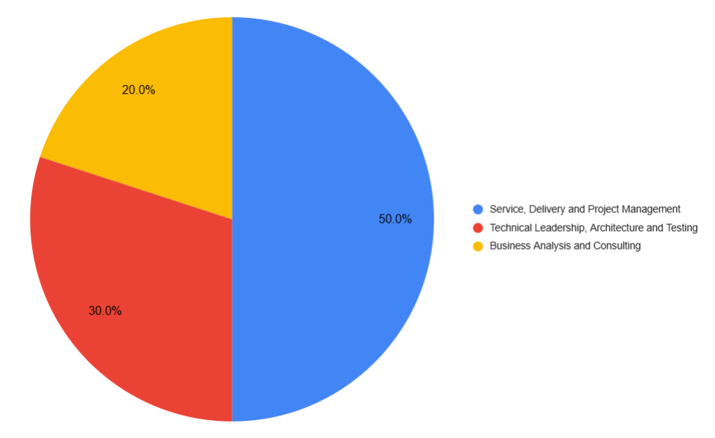
Figure 10 - Distribution of second-iteration respondents by professional role group
The sample was mainly composed of professionals from Service, Delivery and Project Management roles, representing 50.0% of participants, followed by Technical Leadership, Architecture and Testing with 30.0%, and Business Analysis and Consulting with 20.0%. This distribution indicates that the refined artefact was evaluated from complementary professional perspectives, covering both management-oriented and technical viewpoints relevant to AMS assessment contexts.
The second evaluation iteration was conducted through structured interviews supported by the questionnaire. As in the first iteration, this approach ensured that all participants evaluated the same refinement areas and responded to the same set of closed-ended and open-ended questions. The interviews were conducted in two formats, depending on participant availability and logistical constraints: in person and remotely. Although the format varied, the same questionnaire structure was followed in all sessions, ensuring consistency in the data collection process. Table 22 presents the distribution of the second-iteration interviews by format.
Table 22 - Distribution of evaluation sessions by format (2nd iteration)
Format | Number of participants | Percentage
In person | 2 | 20.0%
Remote | 8 | 80.0%
As shown in Table 22, most second-iteration interviews were conducted remotely, representing 80.0% of the total, while 20.0% were conducted in person. This distribution reflects participant availability and scheduling constraints. Since all sessions followed the same questionnaire structure, the use of different formats did not compromise the consistency of the evaluation procedure.
To provide a synthetic view of the second evaluation iteration results, the responses were aggregated according to the four refinement areas addressed in the questionnaire: integration with external systems, AI/NBQ explainability, result interpretation and reporting, and contextual adaptation. For each area, the mean score was calculated based on the corresponding Likert-scale statements, while the percentage of positive responses represents the proportion of answers rated as 4 or 5. Figures 11 and 12 present these two indicators separately, allowing the results to be interpreted both in terms of average agreement and overall positive validation.
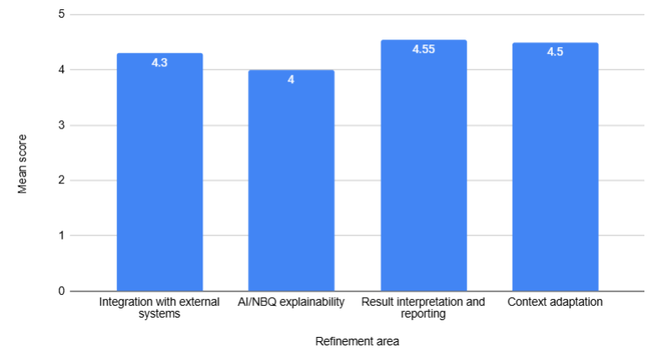
Figure 11 - Mean score by refinement area in the second evaluation iteration

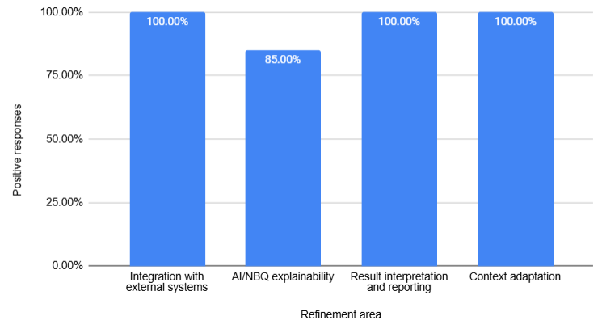
Figure 12 - Positive responses by refinement area in the second evaluation iteration
As shown in Figures 11 and 12, the second evaluation iteration produced highly positive results across all refinement areas. All areas obtained mean scores equal to or above 4.00 on the five-point scale, indicating that respondents generally agreed that the refinements introduced after the first iteration improved the artefact. In addition, three of the four refinement areas obtained 100.0% positive responses, namely integration with external systems, result interpretation and reporting, and contextual adaptation. This suggests that the clarifications and improvements introduced in these areas were consistently validated by the second-iteration participants.
The strongest result was observed in result interpretation and reporting, which obtained the highest mean score, with 4.55, and 100.0% positive responses. This indicates that respondents considered the refined presentation of maturity and risk scores, together with the inclusion of identified gaps and suggested improvement actions, useful for AMS decision-making. This finding is particularly relevant because result interpretation had been identified in the first iteration as an area where numerical scores should be complemented with clearer explanations and more actionable outputs.
Context adaptation also received a very strong evaluation, with a mean score of 4.50 and 100.0% positive responses. This result suggests that the clarification of contextual attributes, such as client characteristics, service and project scope, application criticality and operational constraints, was considered relevant for supporting adaptive question selection in different AMS onboarding scenarios. Since contextual adaptation had already been foreseen in the initial design of the artefact, the second iteration mainly validated that making these attributes more explicit improved the perceived clarity and applicability of the mechanism.
Integration with external systems obtained a mean score of 4.30 and 100.0% positive responses. This is especially important because integration capabilities had represented the lowest-rated functional area in the first evaluation iteration. The second-iteration results suggest clarifying the intended integration scope and identifying relevant external system categories, such as front-end applications, ITSM platforms, issue-tracking or ticketing tools, documentation repositories and reporting platforms, helped address the uncertainty identified in the first cycle. Therefore, the refinement appears to have improved participants’ understanding of how external integrations could support the AMS assessment process.
AI/NBQ explainability obtained the lowest result among the four refinement areas, with a mean score of 4.00 and 85.0% positive responses. Although this area remained comparatively less strongly validated than the others, the result is still positive, as most responses indicated agreement with the refinements introduced. This suggests that the explanations added to clarify why specific questions are selected and how previous answers influence the next-question logic improved the perceived transparency of the adaptive mechanism. At the same time, the slightly lower score indicates that AI/NBQ explainability remains the most conceptually complex area of the artefact, which is expected given the nature of adaptive question selection and AI-supported decision logic.
Overall, the results of the second evaluation iteration indicate that the refinements introduced after the first cycle were positively validated by participants. The areas that had required clarification in the first iteration obtained strong levels of agreement in the second cycle, and no new major refinement theme emerged from the results. Although AI/NBQ explainability remained the lowest-rated area, it still obtained a clearly positive evaluation and did not reveal a recurring need for an additional design iteration.

Chapter 5

Conclusion

References
[1] X. Chen et al., ‘Deep learning-based software engineering: progress, challenges, and opportunities’, Sci. China Inf. Sci., vol. 68, no. 1, p. 111102, Jan. 2025, doi: 10.1007/s11432-023-4127-5.
[2] G. Yu et al., ‘A Survey on Failure Analysis and Fault Injection in AI Systems’, ACM Trans Softw Eng Methodol, May 2025, doi: 10.1145/3732777.
[3] X. Zhang et al., ‘Deep Learning Library Testing: Definition, Methods and Challenges’, ACM Comput Surv, vol. 57, no. 7, Mar. 2025, doi: 10.1145/3716497.
[4] B. Kitchenham, O. Pearl Brereton, D. Budgen, M. Turner, J. Bailey, and S. Linkman, ‘Systematic literature reviews in software engineering – A systematic literature review’, Inf. Softw. Technol., vol. 51, no. 1, pp. 7–15, Jan. 2009, doi: 10.1016/j.infsof.2008.09.009.
[5] H. Chen and M. A. Babar, ‘Security for Machine Learning-based Software Systems: A Survey of Threats, Practices, and Challenges’, ACM Comput Surv, vol. 56, no. 6, Feb. 2024, doi: 10.1145/3638531.
[6] T. Li, C. Cui, R. Huang, D. Towey, and L. Ma, ‘Large Language Models for Automated Web-Form-Test Generation: An Empirical Study’, ACM Trans. Softw. Eng. Methodol., May 2025, doi: 10.1145/3735553.
[7] R. Arisenta, S. Suharjito, and A. Sukmandhani, ‘Evaluation Model of Success Change Management in Banking Institution Based on ITIL V3 (Case Study)’, Aug. 2020, pp. 470–475. doi: 10.1109/ICIMTech50083.2020.9211191.
[8] A. Györy et al., Strategies for Application Management Services. 2012. doi: 10.13140/RG.2.1.4065.7447.
[9] S. Rai, R. C. Belwal, and A. Gupta, ‘A Review on Source Code Documentation’, ACM Trans Intell Syst Technol, vol. 13, no. 5, Jun. 2022, doi: 10.1145/3519312.
[10] O. Pulido-Prieto and U. Juárez-Martínez, ‘A Survey of Naturalistic Programming Technologies’, ACM Comput Surv, vol. 50, no. 5, Sep. 2017, doi: 10.1145/3109481.
[11] S. Gupta and S. K. Gupta, ‘Natural language processing in mining unstructured data from software repositories: a review’, Sādhanā, vol. 44, no. 12, p. 244, Dec. 2019, doi: 10.1007/s12046-019-1223-9.
[12] Y. Song, X. Xie, and B. Xu, ‘When debugging encounters artificial intelligence: state of the art and open challenges’, Sci. China Inf. Sci., vol. 67, no. 4, p. 141101, Apr. 2024, doi: 10.1007/s11432-022-3803-9.
[13] H. Sadler, ‘ER2C SDMLC: enterprise release risk-centric systems development and maintenance life cycle’, Softw. Qual. J., vol. 28, no. 4, pp. 1755–1787, Dec. 2020, doi: 10.1007/s11219-019-09452-7.
[14] O. Özkan, Ö. Babur, and M. Van Den Brand, ‘Refactoring with domain-driven design in an industrial context: An action research report’, Empir. Softw. Eng., vol. 28, no. 4, p. 94, Jul. 2023, doi: 10.1007/s10664-023-10310-1.
[15] J. Cascais Bras, R. F. Pereira, S. Moro, I. S. Bianchi, and R. Ribeiro, ‘Understanding How Intelligent Process Automation Impacts Business Continuity: Mapping IEEE/2755:2020 and ISO/22301:2019’, IEEE Access, vol. 11, pp. 134239–134258, 2023, doi: 10.1109/ACCESS.2023.3337159.
[16] J. C. Brás, R. F. Pereira, M. Fonseca, R. Ribeiro, and I. S. Bianchi, ‘Advances in auditing and business continuity: A study in financial companies’, J. Open Innov. Technol. Mark. Complex., vol. 10, no. 2, p. 100304, Jun. 2024, doi: 10.1016/j.joitmc.2024.100304.
[17] J. Rzeniewicz, J. Szymański, and W. Duch, ‘Adaptive Algorithm for Interactive Question-Based Search’, in Intelligent Information Processing VI, vol. 385, Z. Shi, D. Leake, and S. Vadera, Eds, in IFIP Advances in Information and Communication Technology, vol. 385. , Berlin, Heidelberg: Springer Berlin Heidelberg, 2012, pp. 186–195. doi: 10.1007/978-3-642-32891-6_24.
[18] D. Witt and M. Rösner, ‘Joining Artificial and Human Intelligence’, ATZ Worldw., vol. 123, no. 5, pp. 60–63, May 2021, doi: 10.1007/s38311-021-0657-y.
[19] D. McSherry, ‘Mixed-initiative problem solving with decision trees’, Artif. Intell. Rev., vol. 28, no. 1, pp. 17–33, Jun. 2007, doi: 10.1007/s10462-008-9079-0.
[20] D. Mcsherry, ‘Interactive Case-Based Reasoning in Sequential Diagnosis’, Appl. Intell., vol. 14, no. 1, pp. 65–76, Jan. 2001, doi: 10.1023/A:1008355024844.
[21] S. Tuval and B. Shapira, ‘The Next Best Question: a lazy, anytime framework for adaptive feature acquisition’, in Proceedings of the 36th Annual ACM Symposium on Applied Computing, in SAC ’21. New York, NY, USA: Association for Computing Machinery, Apr. 2021, pp. 1078–1081. doi: 10.1145/3412841.3442104.
[22] K. Peffers, T. Tuunanen, M. Rothenberger, and S. Chatterjee, ‘A Design Science Research Methodology for Information Systems Research’, J. Manag. Inf. Syst., vol. 24, no. 3, pp. 45–77, Fall 2007, doi: 10.2753/MIS0742-1222240302.

Appendices

Appendix A

Method | URL | Parameter(s) | Output(s)
POST | /login | Username | (200) Token Session
 |  | Password | (401) Authentication failed

The Login endpoint provides the mechanism through which users authenticate before accessing the assessment artifact. It receives a POST request containing two input parameters — username and password — submitted in the body of the request. These credentials are validated by the backend, which confirms the identity of the user and verifies that the account is active and authorized to interact with the system. Upon successful authentication, the endpoint returns a session token, typically implemented as a JSON Web Token (JWT), which encapsulates essential information such as the user’s identity, assigned roles and token expiry. This output enables subsequent requests to be authorized without requiring the storage of session state on the server, ensuring secure, efficient and stateless interaction with the backend layer. In case the authentication attempt is unsuccessful — either because the username does not correspond to an existing account or because the provided password is incorrect — the Login endpoint returns an HTTP 401 Unauthorized response. This status code indicates that the authentication process failed and no session token has been issued. To avoid leaking information that could facilitate user enumeration or other malicious activity, the system deliberately returns a generic error message without specifying whether the failure resulted from an unknown user or an incorrect password. This behavior aligns with security best practices and ensures that the authentication mechanism remains resilient while still clearly signaling that access has not been granted.

Table 5 – Admin endpoint for listing users.
Method | URL | Parameter(s) | Output(s)
GET | /admin/users | Role (optional) | (200) User list
 |  | Status (optional) | (403) Unauthorized operation

The GET /admin/users endpoint allows authorized administrative users to retrieve the list of registered accounts in the system. Optional query parameters, such as role and status, may be supplied to filter the results according to specific administrative needs. When the request is valid and the caller possesses the required administrative privileges, the endpoint returns the corresponding user list. If the requester lacks the appropriate permissions, the backend responds with an HTTP 403 Forbidden status, preventing unauthorized access to user management operations.
Table 6 presents the administration endpoint used to create new user accounts in the system.
Table 6 - Admin endpoint for creating new users.
Method | URL | Parameter(s) | Output(s)
POST | /admin/users | Body: Username | (200) New User’s information
 |  |  | (403) Unauthorized operation
 |  | Body: Email | (400) Bad Request
 |  | Body: Initial Password
 |  | Body: Roles

The POST /admin/users endpoint enables authorized administrators to create new user accounts within the system. A valid request must include the required parameters — username, email, initialPassword and a list of roles — all of which are validated to ensure that the new account can be properly registered. When the submitted data is complete and correctly formatted, and the requester holds the appropriate administrative privileges, the backend creates the new user and returns a 200 OK response containing the newly generated account information.
In contrast, if the request body is malformed, missing mandatory fields, contains invalid role definitions or attempts to create a user with a username or email already registered in the system, the endpoint responds with a 400 Bad Request, indicating that the issue lies in the submitted data. Additionally, if the requester does not possess administrative permissions, the backend rejects the operation with a 403 Forbidden, preventing unauthorized manipulation of user accounts. This behavior ensures both the correct functioning of the user management process and the enforcement of strict access governance.

Table 7 presents the administration endpoint used to update the operational status of an existing user account. This operation allows authorized administrators to activate, deactivate, or otherwise modify a user’s account state by specifying the target user and the new status value.Table 7 - Admin endpoint for updating a user’s status
Method | URL | Parameter(s) | Output(s)
PATCH | /admin/users/{userId}/status | Path: userId | (200) Account’s state updated
 |  |  | (403) Unauthorized operation
 |  | Body: status | (400) Bad Request
 |  |  | (404) User not found

The PATCH /admin/users/{userId}/status endpoint allows authorized administrators to modify the operational state of an existing user account, enabling actions such as activating or disabling access to the system. The request must specify the target userId as a path parameter and include the new status value in the request body. When both the identifier and the status are valid, and the requester holds the necessary administrative privileges, the backend updates the user’s record accordingly and returns a 200 OK response confirming the new state.
If the request contains invalid data—such as an unsupported status value—or if the user identifier does not correspond to any registered account, the endpoint responds with a 400 Bad Request or 404 Resource Not Found, respectively. Additionally, if the caller lacks the required administrative permissions, the system issues a 403 Forbidden to prevent unauthorized state changes. This endpoint ensures that user lifecycle management is both controlled and auditable, supporting the governance requirements typical of AMS environments.

Table 8 presents the administration endpoint used to update the roles assigned to an existing user account.
Table 8 - Admin endpoint for updating a user’s roles
Method | URL | Parameter(s) | Output(s)
PATCH | /admin/users/{userId}/roles | Path: userId | (200) User’s roles updated
 |  |  | (403) Unauthorized operation
 |  | Body: roles | (400) Bad Request
 |  |  | (404) User not found

The PATCH /admin/users/{userId}/roles endpoint allows authorized administrators to modify the set of roles associated with an existing user account. The request specifies the target userId as a path parameter and provides the new list of roles in the request body. When the identifier is valid, the supplied roles correspond to recognized profiles in the system and the caller holds the necessary administrative privileges, the backend updates the user record accordingly and returns a 200 OK response confirming the new set of roles. If the request contains invalid data—for example, an empty role list or roles that are not defined in the system—or if the body is malformed, the operation results in a 400 Bad Request. When the specified user cannot be found, the endpoint returns 404 Resource Not Found, whereas attempts made by non-administrative users are rejected with 403 Forbidden, thereby preventing unauthorized changes to access rights.

Table 9 presents the administration endpoint used to update the password of an existing user account.
Table 9 - Admin endpoint for updating a user’s password
Method | URL | Parameter(s) | Output(s)
PATCH | /admin/users/{userId}/roles | Path: userId | (200) Password updated
 |  |  | (403) Unauthorized operation
 |  | Body: newPassword | (400) Bad Request
 |  |  | (404) User not found

The PATCH /admin/users/{userId}/password endpoint enables authorized administrators to reset or update the password associated with an existing user account. The request includes the target userId as a path parameter and the new password value in the request body. When the provided data is valid and the caller possesses administrative privileges, the backend updates the user’s credentials and returns a 200 OK response. If the request is malformed or contains a password that does not meet the required validation criteria, the system responds with a 400 Bad Request. Attempts to update a password for a non-existent user result in a 404 Not Found, while users lacking the appropriate administrative permissions receive a 403 Forbidden response. This endpoint supports secure lifecycle management of user credentials and reinforces access governance within the system.

Table 10 - Endpoint used to create a new client associated with the authenticated user.
Method | URL | Parameter(s) | Output(s)
GET | /clients | Query: name | (200) Client list
 |  | Query: industry | (403) Forbidden request
 |  | Query: geoArea
 |  | Query: page | (400) Bad Request
 |  | Query: size

As seen in Table 10, the GET /clients endpoint returns the list of clients previously created by the authenticated user, optionally filtered by attributes such as name, industry or geographic area. Pagination parameters may also be supplied to limit the size of the returned dataset. When the request is valid and the caller is authorized to access client information, the server responds with a 200 OK containing the filtered list of clients associated with that user. Invalid or malformed query parameters result in a 400 Bad Request, while attempts made by users who lack the necessary permissions lead to a 403 Forbidden response. This endpoint ensures that users can efficiently retrieve and manage only the clients they own, reinforcing data isolation and contextual relevance within the AMS ecosystem.

Table 11 presents the endpoint used to create a new client record associated with the authenticated user.
Table 11 - Endpoint used to create a new client.
Method | URL | Parameter(s) | Output(s)
POST | /clients | Body: name | (200) New client created
 |  | Body: industry | (403) Unauthorized operation
 |  | Body: geoArea
 |  |  | (400) Bad Request

The POST /clients endpoint allows authenticated users to register a new client in the system. The request body must include the client’s name, industry and geographic area, which are validated to ensure that the record can be consistently stored. When the submitted data is valid and the caller is authorized to manage clients, the backend creates the new entry, associates it with the current user and returns a 200 OK response containing the newly created client’s basic information. If mandatory fields are missing, contain invalid values or violate uniqueness constraints (for example, attempting to create a duplicate client), the operation results in a 400 Bad Request. When the requester lacks the necessary permissions to perform client management operations, the server responds with 403 Forbidden, thereby preventing unauthorized creation of client records.

Table 12 presents the endpoint used to update the information of an existing client.
Table 12 - Endpoint used to update the information of an existing client.
Method | URL | Parameter(s) | Output(s)
PATCH | /clients/{clientId} | Path: clientId | (200) Client updated
 |  | Body: newName | (403) Forbidden request
 |  | Body: newIndustry
 |  | Body: newGeoArea | (400) Bad Request
 |  |  | (404) Client not found

The PATCH /clients/{clientId} endpoint allows authorized users to modify the attributes of an existing client, including its name, industry and geographic area. Only the fields supplied in the request body are updated, enabling partial and flexible modifications while preserving the rest of the client’s data. When the request is valid, the user has sufficient permissions and the specified client exists, the backend updates the corresponding record and returns a 200 OK response.
If the payload contains invalid values, violates validation rules or is syntactically incorrect, the operation results in a 400 Bad Request. Attempts to update a client that does not exist return a 404 Not Found, while callers without the necessary permissions receive a 403 Forbidden response.

Table 13 presents the endpoint used to retrieve the list of projects associated with a specific client.
Table 13 - Endpoint used to retrieve the list of projects associated with a specific client.
Method | URL | Parameter(s) | Output(s)
GET | /clients/{clientId}/projects | Path: clientId | (200) Client’s project list
 |  |  | (403) Forbidden request
 |  |  | (404) Client not found

The GET /clients/{clientId}/projects endpoint retrieves all projects associated with the selected client. It is used to populate the project table displayed in the client profile page. When a valid client identifier is provided and the caller has sufficient permissions, the backend returns a 200 OK containing the list of projects owned by that client. If the client does not exist, the response is 404 Client Not Found, whereas requests from users without adequate privileges result in 403 Forbidden.

Table 14 presents the endpoint used to create a new project associated with a specific client.
Table 14 - Endpoint used to create a new project for a specific client
Method | URL | Parameter(s) | Output(s)
POST | /clients/{clientId}/projects | Path: clientId | (200) New client project information
 |  | Body:  context | (403) Forbidden request
 |  |  | (404) Client not found
 |  |  | (400) Bad request

The POST /clients/{clientId}/projects endpoint allows users to register a new project under an existing client by specifying the context in which Business Continuity and Change Management will be assessed. The request includes the clientId as a path parameter and a context value in the body, indicating whether the assessment will be conducted from a Business, Technical, Service Delivery, or Security & Compliance perspective. When the client exists, the context value is valid and the caller has sufficient permissions, the backend creates the project, associates it with the selected client and returns a 200 OK response containing the new project identifier, its context and creation timestamp. Invalid or missing context values result in a 400 Bad Request, while attempts to create a project for a non-existent client yield 404 Client Not Found. If the requester lacks the necessary access rights, the operation is rejected with 403 Forbidden, ensuring that project creation remains controlled and auditable.

Table 15 presents the endpoint used to update the context list of an existing project associated with a specific client.
Table 15 - Endpoint used to update the context list of a project associated with a given client.
Method | URL | Parameter(s) | Output(s)
PATCH | /clients/{clientId}/projects/{projectId} | Path: clientId | (200) New client project information
 |  | Path: projectId
 |  | Body:  Context list | (403) Forbidden request
 |  |  | (404) Client/Project not found
 |  |  | (400) Bad request

The PATCH /clients/{clientId}/projects/{projectId} endpoint allows authorized users to update the context list associated with an existing project under a specific client. The request identifies both the client and the project through path parameters and supplies the revised set of contexts in the request body, for example combining Business, Technical, Service Delivery and Security & Compliance perspectives. When the client and project exist, the caller has sufficient permissions and the payload is valid, the backend updates the project record and returns a 200 OK response with the updated project information. Invalid or inconsistent data in the body results in a 400 Bad Request, while attempts to modify a project or client that cannot be found return 404 Not Found. If the requester lacks the necessary privileges to perform the update, the operation is rejected with 403 Forbidden, ensuring that project configuration remains controlled and auditable.

Table 16 presents the endpoint used to retrieve the list of assessments associated with a specific project.
Table 16 – Endpoint used to retrieve the list of assessments associated with a specific project
Method | URL | Parameter(s) | Output(s)
GET | /clients/{clientId}/projects/{projectId}/  assessments | Path: clientId | (200) Project’s assessment list
 |  | Path: projectId
 |  |  | (403) Forbidden request
 |  |  | (404) Client or Project not found

The GET /clients/{clientId}/projects/{projectId}/assessments endpoint retrieves the list of all assessments previously executed within a specific project. Because assessments are strictly contextualized by both client and project, the endpoint enforces a hierarchical access structure, requiring valid identifiers for both resources. When the client and project exist and the caller is authorized to access them, the backend returns a 200 OK response containing a structured list of assessments, typically including their identifiers, execution dates, maturity scores and status. Requests issued with insufficient privileges result in 403 Forbidden, while attempts to access assessments for a client or project that does not exist lead to a 404 Not Found response. This design ensures consistent scoping of assessments, prevents cross-tenant data exposure and provides a reliable entry point for rendering the project detail view in the front-end.

Table 17 – Endpoint used to create a new assessment
Method | URL | Parameter(s) | Output(s)
POST | /clients/{clientId}/projects/{projectId}/  assessments | Path: clientId | (200) New assessment created
 |  | Path: projectId
 |  | Body: assessmentType | (403) Forbidden request
 |  | Body: context | (404) Client or Project not found
 |  | Body: clientRepresentative | (400) Bad request

The POST /clients/{clientId}/projects/{projectId}/assessments endpoint initiates a new assessment for a specific client and project. The request must include the assessment type, the selected evaluation context and the name of the client representative involved in the process. When the client and project exist, the caller is authorized and the payload is valid, the backend creates a new assessment instance and immediately triggers the selection of the first question. This selection is not predefined: it is generated dynamically by the AI-based NBQ module, which evaluates the assessment’s initial parameters to determine the most appropriate starting point. The response therefore returns a 200 OK containing the newly created assessment identifier, its initial metadata (such as type, context and timestamp), together with the first question, its explanatory notes and the corresponding answer options. Invalid or missing fields lead to a 400 Bad Request, while insufficient permissions result in 403 Forbidden. If either the client or the project cannot be found, the server returns 404 Not Found, ensuring that the assessment workflow always begins in a valid, scoped and AI-informed context.

Table 18 presents the endpoint used to retrieve the next question within an ongoing assessment.
Table 18 - Endpoint used to retrieve the next question of an existing assessment identified by its assessmentId
Method | URL | Parameter(s) | Output(s)
GET | /assessments/{assessmentId}/next-question | Path: assessmentId | (200) Question, explanation and options
 |  |  | (403) Forbidden request
 |  |  | (404) Assessment not found
 |  |  | (400) Bad request
 |  |  | (204) No more questions

The GET /assessments/{assessmentId}/next-question endpoint returns the next question to be answered in an existing assessment. The backend first verifies that the assessment exists and that the caller is authorized to access it. It then delegates the selection of the next question to the AI-based NBQ module, which analyzes the assessment context and the answers already provided to determine the most appropriate follow-up question. When a new question is available, the endpoint responds with 200 OK, returning the question text, its explanatory information, the question type (single or multiple choice) and the corresponding answer options. If the assessment has no further questions to present, the endpoint returns 204 No Content, indicating that the assessment has reached its end. Invalid requests result in 400 Bad Request, unauthorized access attempts are rejected with 403 Forbidden, and references to non-existent assessments produce a 404 Assessment Not Found response.

Table 19 presents the endpoint used to submit an answer for the current question of an ongoing assessment.
Table 19 – Endpoint used to submit an answer for the current question of an assessment
Method | URL | Parameter(s) | Output(s)
POST | /assessments/{assessmentId}/answers | Path: assessmentId | (200) Answer Recorded
 |  | Body: questionAsked | (400) Bad Request
 |  | Body: selectedAnswerIds | (403) Forbidden request
 |  |  | (404) Assessment not found

The POST /assessments/{assessmentId}/answers endpoint records the answer provided by the user for the current question of an ongoing assessment. The request body includes the identifier of the question presented to the user and the selected answer option(s), supporting both single- and multiple-choice formats. When the assessment exists and the caller is authorized, the backend validates that the submitted questionAskedId corresponds to a question previously issued within that assessment. If the payload is valid and consistent, the system stores the answer and returns a 200 OK response. Invalid or inconsistent request bodies—such as referencing a question that was not asked in the assessment or specifying answer options that do not belong to that question—result in a 400 Bad Request. Requests from users lacking permissions are rejected with 403 Forbidden, while attempts to submit answers to a non-existent assessment return 404 Not Found.

Table 20 presents the endpoint used to retrieve the results of a completed assessment. This operation returns the calculated maturity score and readiness indicators associated with the selected assessment, allowing users to analyze the outcome of the evaluation.
Table 20 – Endpoint used to get the results of an assessment
Method | URL | Parameter(s) | Output(s)
GET | /assessments/{assessmentId}/results | Path: assessmentId | (200) Maturity score + readiness indicators
 |  |  | (403) Forbidden request
 |  |  | (404) Assessment Not Found

After the assessment questions have been completed, the system must expose the resulting evaluation metrics generated by the scoring engine. The GET /assessments/{assessmentId}/results endpoint provides access to the maturity level calculated from the answers submitted during the assessment. When the assessment exists and the requester is authorized, the endpoint returns the computed maturity indicators, readiness scores and any associated risk metrics. If the assessment cannot be found, the system responds with 404 Not Found, while unauthorized access attempts result in 403 Forbidden.

Table 21 presents the endpoint used to retrieve the full report of a completed assessment.
Table 21 – Endpoint used to get the assessment’s report
Method | URL | Parameter(s) | Output(s)
GET | /assessments/{assessmentId}/report | Path: assessmentId | (200) Full assessment report
 |  |  | (403) Forbidden request
 |  |  | (404) Assessment Not Found

The GET /assessments/{assessmentId}/report endpoint provides a consolidated view of the completed assessment. It returns a structured report containing the questions asked, the answers provided, the calculated maturity levels and the associated evaluation metrics. This endpoint supports the reporting and output generation domain of the artifact, enabling results to be visualized in the front-end or exported to other organizational systems for further analysis.

Table 22 presents the endpoint used to retrieve the current status of a specific assessment.
Table 22 – Endpoint used to get the status of a specific assessment
Method | URL | Parameter(s) | Output(s)
GET | /assessments/{assessmentId}/report | Path: assessmentId | (200) Full assessment report
 |  |  | (403) Forbidden request
 |  |  | (404) Assessment Not Found

The GET /assessments/{assessmentId}/status endpoint allows client applications to retrieve the current state of an assessment session. The response typically indicates whether the assessment is in progress, completed, or interrupted, together with metadata such as the number of answered questions and the timestamp of the latest interaction.

